**CCNP Enterprise Course**

**Including 24 Sessions**

# **Network Architectures – Big Picture**

* Different Architectures Overview
  + Enterprise Hierarchical Architecture
  + Data Center Spine-Leaf Architecure
  + Cloud-Based Architecture
* Hierarchica LAN Design Model
  + A hierarchical LAN design model divides the enterprise network architectures into modular layers. By breaking up the design into modular layers, you can have each layer to implement specific functions
  + The Hierarchical LAN design divides networks or their modular blocks into the following three layers:
    - Access Layer: Gives endpoints and users direct access to the network
    - Distribution/Aggregation Layer: Provides an aggregation point for the access layer and acts as a service and control boundary between the access layer and the core layer.
    - Core Layer / Backbone: Provides connections between distribution layers for large environments

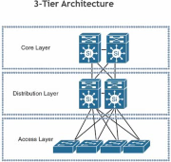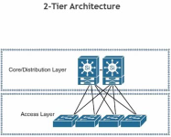

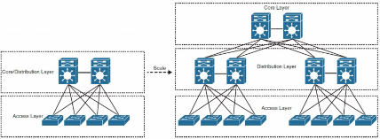

* Enterprise Network Architecture Options
  + Two-tier design (collapsed core)
  + Three-tier design
  + Layer 2 access layer (STP based)
  + Layer 3 access layer (routed access)
  + Simplified campus design
  + Software-Defined Access (SD-Access)
* Two-Tier Design (Collapsed Core)
  + Smaller campus networks may have multiple departments spread across multiple floors within a building. In these environments, a core layer may not be needed, and collapsing the core function into the distribution layer can be a cost-effective solution (as no core layer means no core layer devices)

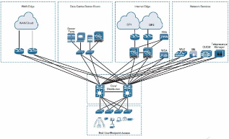

* Three-Tier Design
  + Three-tier designs separate the core and distribution layers and are recommended when more than two pairs of distribution switches (switch blocks) are required. Multiple pairs of distribution switches are typically required for the following reasons:
    - When implementing a network for a large enterprise campus composed of **multiple buildings**, where each building requires a dedicated distribution layer
    - When the density of WAN routers, Internet edge devices, data center servers, and network services are growing to the point where they can **affect network performance and throughput**.
    - When **geographic dispersion** of the LAN access switches across many buildings in a large campus facility would require more fiber-optic interconnects back to a single collapsed core.

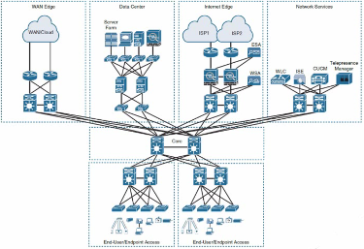

* Layer 2 access layer (STP Based)
  + Traditional Lan design use a layer 2 access layer and a layer 3 distribution layer.
    - The distribution layer is the layer 3 IP gateway for access layer hosts
  + The looped design in layer 2 networks, causes STP to block links, which reduces the bandwidth from the rest of the network and can cause slower network convergence.
  + It is recommended to restrict a VLAN to a single access layer switch to eliminate topology loops.
    - Restricting a VLAN to a single switch provides a loop-free design, but at the cost of network flexibility because all hosts within a VLAN are restricted to a single access switch. Some organizations require that the same layer 2 VLAN be extended to multiple access layer switches to accommodate an application or a service

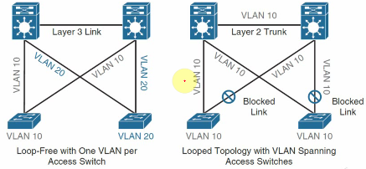

* + It needs Highly Available IP Gateway at the Distribution Layer:
    - To create a highly available IP gateway at the distribution layer, the distribution layer should have a pair of standalone switches configured with First-Hop Redundancy Protocols (FHRPs)
    - FHRP includes:
      * Hot Standby Router Protocol (HSRP)
      * Virtual Router Redundancy Protocol (VRRP)
      * Gateway Load Balancing Protocol (GLBP)
* Layer 3 access layer (Routed Access)
  + Routed access in an alternative configuration in which layer 3 is extended all the way to the access layer switches
    - In this design:
      * Access layer switches act as full layer 3 routed nodes (providing both layer 2 and layer 3 switching)
      * The access-to-distribution layer 2 uplink trunks are replaced with layer 3 point-to-point routed links
      * The layer 2/layer 3 demarcation point is moved from the distribution switch to the access switch

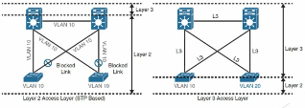

* + **No first-hop redundancy protocol required**: It eliminates the need for first-hop redundancy protocols such as HSRP and VRRP.
  + **No STP required**: Because there are no layer 2 links to blocks, this design eliminates the need for STP.
  + **Increased uplink utilization**: both uplinks from access to distribution can be used, increasing the effective bandwidth available to the end users and endpoints connected to the access layer switches.
  + **Easier** **troubleshooting**: It offers common end-to-end troubleshooting tools (such as **ping** and **traceroute**)
  + **Faster convergence**: It uses fast-converging routing protocols such as Enhanced Interior Gateway Routing Protocol (EIGRP) and Open Shortest Path First (OSPF).
* Simplified Campus Design
  + The simplified campus design relies on switch clustering such as a Virtual Switching System (VSS) and stacking technologies such as StackWise.
  + In this design:
    - Multiple physical switches act as a single logical switch
    - Clustering and stacking technologies can be applied to any of the campus buildings

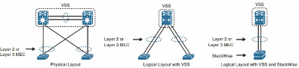

* + Using this design offers the following advantages:
    - **Simplified design**: By using the single logical distribution layer design, there are fewer boxes to manage, which reduces the amount of time spent on ongoing provisioning and maintenance.
    - **No first**-**hop redundance protocol required**
    - **Reduced STP dependence**: Because EtherChannel is used, it eliminates the need for STP for a layer 2 access design; however, STP is still required as a failsafe in case multiple access switches are interconnected.
    - **Increased Uplink Utilization**: With EtherChannel, all uplinks from access to distribution can be used, increasing the effective bandwidth available to the end users and endpoints connected to the access layer switches.

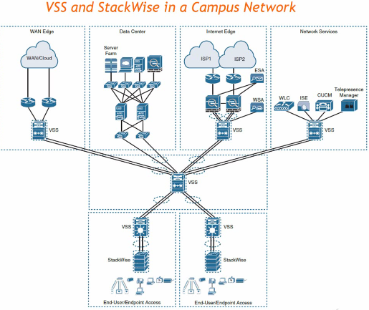

* Software-Defined Access (SD-Access)
  + SD-Access= Campus Fabric + Cisco DNA Center

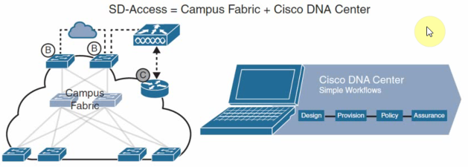

* Data Center – Spine-Leaf Architecture

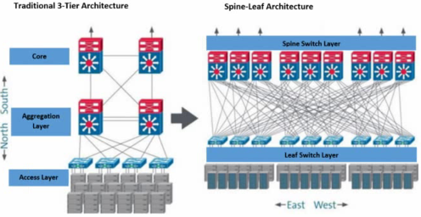

* Cloud-Based Architecture

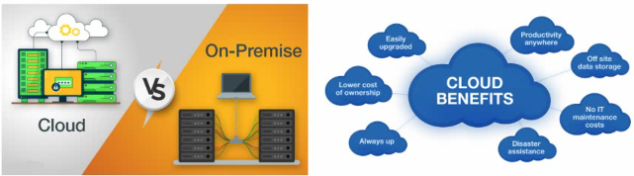

# **Layer 2 Forwarding – Vlans and Trunking**

* VLAN Packet Structure
  + Vlans are defined in the IEEE 802.1Q standard, which states that 32 bits are added to the packet header in the following fields:
  + Tag Protocol Identifier (TPID): This 16-bit is field set to 0x8100 to identify the packet as an 802.1Q packet
  + Priority Code Point (PCP): This 3-bit field indicates a Class of Service (CoS) as part of Layer 2 QoS between switches
  + Drop Eligible Indicator (DEI): This 1-bit field indicates whether the packet can be dropped when there is bandwidth contention.
  + VLAN Identifier (VLAN ID): This 12-bit field specifies the VLAN associated with a network packet.

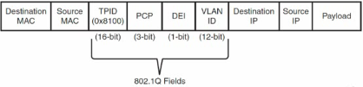

* VLAN Categories
  + Standard (1-1005)
  + Extended (1006-4094)
  + Internal
* Standard VLANS
  + VLAN 1
    - Default Ethernet Access VLAN & default 802.1q native vlan
    - Cannot be deleted, but can be manually pruned from trunks
    - Cannot be pruned by VTP
    - Should not be used for actual port assignments
  + VLAN 1002-1005
    - Default legacy Token Ring / FDDI VLANs
* Extended VLANS
  + Can normally only used in one of two cases
    - VTP is configured in Transparent Mode
    - VTP version 3
  + Not all extended VLANs can be used
    - Some are reserved for internal VLANs
* Internal VLANS
  + VLANs reserved for internal usages
  + *Show vlan internal usage*
  + Not all platforms agree on internal ranges
    - For real deployments, check the internal allocations
    - Some allocated ascending, some descending
* End-to-End VLANS
  + Each VLAN is distributed geographically throughout the network
  + Users are grouped into each VLAN regardless of the physical location, theoretically easing network management
  + As a user moves throughout a campus, the VLAN membership for that user remains the same
  + Switches are configured for VTP server or client mode

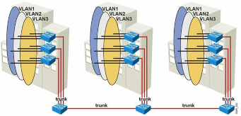

* Local VLANS
  + Create local VLANs with physical boundaries in mind rather than job functions of the users
  + Local VLANs exist between the access and distribution layers
  + Traffic from a local VLAN is routed at the distribution and core levels
  + Switches are configured in VTP transparent mode

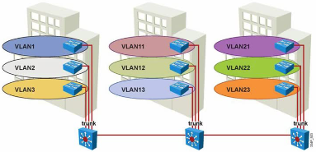

* Configuration - Creating VLANS
  + VLANs can be created through:
    - Globally
    - VLAN database
    - At the time of assignment
  + Creating a VLAN automatically creates:
    - Spanning-tree instance
    - MAC address table
* Ethernet Port Types
  + Layer 2 switch ports
    - Access
    - Trunk
    - Tunnel
    - Dynamic
  + Layer 3 Ports
    - Switched Virtual Interface (SVI)
    - Native Routed Interface
* Layer 2 Trunking
  + IEEE 802.1Q
    - Open standard
    - “Native” VLAN sent untagged
  + DTP
    - Dynamic Trunking Protocol
  + Verified with these commands:
    - Show interfaces trunk
    - Show interfaces switchport
    - Show spanning-tree [vlan | interface]
* Disabling DTP Negotiation
  + Can be disabled by:
    - Switchport nonegotiate
    - Switchport mode access
    - Switchport mode dot1q-tunnel
  + Verified with this command:
    - Show interface “X” switchport

# **VTP – VLAN Trunking Protocol**

* VTP is a Cisco-proprietary protocol that automates the propagation of VLAN information between switches via trunk links
* It simplifies the management of VLANs
* VTP does not configure switch ports for VLAN membership
* Three types of VTP messages are sent via Layer 2 multicast on VLAN 1
* VTP Modes
  + Server
    - Can create, modify and delete VLANs
    - Sends and forwards advertisements to other switches
    - Synchronizes VLAN configuration with latest information received from other switches in the management domain
  + Client
    - Cannot create, change, or delete VLANs
    - Forwards advertisements to other switches
    - Synchronizes VLAN configuration with latest information received from other switches in the management domain
  + Transparent
    - Can create, modify, and delete VLANs only on the local switch
    - Forwards VTP advertisements received from other switches in the same management domain
    - Does not synchronize its VLAN configuration with information received from other switches in the management domain
* VTP Message Types
  + Summary Advertisement
  + Advertisement Requests
  + Subset Advertisements
* Potential problems of VTP
  + Wrong database with high configuration version number can overwrite the database
  + True for both VTP servers and clients
  + Reason that VTP v1/v2 is rarely used in production
* VTP Versions
  + Three VTP versions: V1, V2, V3
  + Versions are not interoperable (e.g., V2 supports token ring VLANs but V1 does not)
  + V1 transparent switches inspect VTP messages for the domain name and version and forward a message only if the version and domain name match. V2 transparent switches forward VTP messages in transparent mode without checking versions
  + V2 performs VLAN consistency checks (VLAN names and values) only when you enter new information through the CLI or via SNMP. V2 does not perform checks when new information is obtained from a VTP message or when information is read from NVRAM. If the MD5 hash on a received VTP message is correct, V2 accepts the VTP message information
* VTP Pruning
  + Reduces unnecessary replication of:
    - Broadcasts
    - Unknown unicast
    - Unknown multicast
* VTP Pruning Problems
  + What if all devices don’t support pruning?
    - VTP is Cisco proprietary
  + What if devices don’t agree on the VTP Revision number?
  + What if there are VTP Transparent Switches?
* VTP Version 3 Enhancements
  + Security Enhancements
    - Fixes configuration revision overwrite problem
  + New advertisements
    - Extended VLANs
    - Private VLANs
    - MST configuration
  + VTP can now be disabled
    - Globally
    - Per link

# **EtherChannel**

* EtherChannel Definition
  + EtherChannel is a method for aggregating the bandwidth of physical links
  + Also called:
    - Link Aggregation (LAG)
    - Channeling
    - NIC Teaming
    - Port Channels
* EtherChannel Components
  + Port-Channel interface
    - Logical interface representing the link bundle
  + Member interfaces
    - Physical links that are part of the link bundle
  + The goal is to hide the member interfaces from the upper layer protocols. For example, STP sees one 2Gbps links not 2x1 Gbps links
  + Result is active/active forwarding instead of active/standby with STP

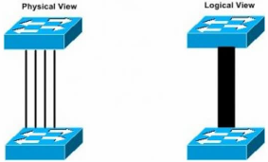

* Advantages and disadvantages of EtherChannel
  + Advantages:
    - Cheap incremental upgrade solution
      * 2 x 10G links often cheaper than 40 or 100G links
    - Adds link layer redundancy
      * 2 x 10G links has better resiliency than 1 x 40G link
  + Disadvantages:
    - Flows cannot exceed the bandwidth of an individual link
      * 2Gbps LAG is not a 2Gbps pipe, but 2 x 1Gbps pipes
    - Flows can land on only one member of the LAG
      * LAG supports load distribution but not load balancing
      * 1 x 40G get better throughput than 4 x 10G links
* EtherChannel Designs (Single-Chassis & Multi-Chassis)
  + EtherChannel cause fate sharing at the access layer
    - Servers may have redundant power, redundant NICs, but what happens if the access switch goes down?
    - What is the solution?
      * Use two access layer switches
        + Problem is that NICs usually only support active/standby outside of LAG
        + So 50% of bandwidth is lost
      * Trick the server into running LAG
        + Form a logical chassis between two physical switches
        + Result is that the server thinks it has two connections to the same switch
        + Now 100% of the bandwidth can be used and more resiliency is added

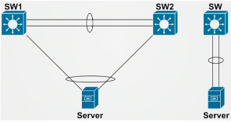

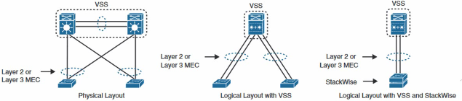

* Multi-Chassis EtherChannel (MCEC)
  + Turn physical triangle into logical P2P link
    - Downstream device thinks upstream devices are one
    - This is what allows active/active
  + MCEC/MLAG relies on synchronized control plane between switches
    - Forward the data plane out member port both chassis
    - Synchronized the control plane on the backend transparently
    - Synchronization is proprietary and not inter-operable
* How Cisco implement MCEC?
  + StackWise Cross-Stack EtherChannel
    - Access Platforms (Catalyst 3750/3850)
    - Control plane sync over dedicated stacking cables
    - Stack cable creates a bidirectional closed-loop
    - One control plane is shared among stack members
    - One management plane is shared among stack members
  + Virtual Switching System (VSS)
    - Aggregation platforms (4500/6500/6800)
    - Control plane sync over Virtual Switch Link (VSL)
      * Typically 2 x 10G LAG
    - One control plane is shared among VSS
    - One management plane is shared among VSS
    - Usually 1 active supervisor and 3 standby supervisors

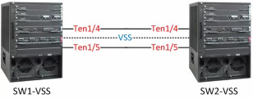

* + Virtual Port Channel (vPC)
    - Data Center Platforms (Nexus 5000/7000/9000)
    - Control plane sync over a vPC peer link
      * Typically 2 x 10G LAG
    - Two independent control planes in the vPC
    - Two independent management planes in the vPC
    - Usually 2 active supervisors and 2 standby supervisors
* Differences between StackWise/VSS/vPC
  + StackWise can have more than 2 members, up to the stack limit
    - Stack limit depends on platform (3750-X supports 9 boxes in the stack)
  + VSS and vPC are always a pair of switches
  + Logical result of all three is the same
    - Turns a physical triangle into a logical P2P link
* EtherChannel Negotiation Protocols
  + Link aggregation goal is to trick STP into forwarding active/active
    - Risk is now an infinite loop in the data plane
    - Negotiation protocols help to mitigate this risk
  + Link aggregation negotiation comes in two forms
    - Port Aggregation Protocol (PAgP) (Cisco proprietary)
    - Link Aggregation Control Protocol (LACP)
  + Static aggregation is supported but not recommended
    - Failure to LAG can cause an STP loop
    - EtherChannel Guard can help mitigate this
  + Dynamic Channel Protocols
    - PAgP
      * Cisco proprietary
      * Essentially pre-standard LACP
    - LACP
      * Initially IEEE 802.3ad and then 802.1ax
* EtherChannel Negotiation Modes
  + Mode determines how negotiation occurs
  + PAgP Modes:

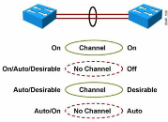

* + LACP Modes:

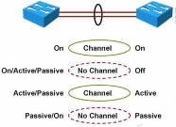

* EtherChannel Load Balancing
  + Link aggregation is responsible for load distribution amongst members
    - STP & CAM table see LAG as outgoing interface, not members
  + EtherChannel load balancing methods are different based on platforms
    - Source & Destination MAC address
    - Source & Destination IP address
    - Source & Destination Layer 4
  + Balancing method is locally significant and aoutbound
    - Mismatching an ether end is ok
    - Adjustment should be made based on traffic patterns to prevent traffic polarization
* EtherChannel (Layer 2 vs. Layer 3)
  + Link aggregation is independent of port mode
    - LAG can be access, trunk, tunnel, layer 3
  + LAG commonly suffers from order of operations issues
    - Members and LAG interfaces must agree on parameters
* LACP System Priority
  + The LACP system priority identifies which switch is the master switch for a port channel
  + The master switch on a port channel is responsible for choosing which member interfaces are active in a port channel
  + When there are more member interfaces than the maximum number of member interfaces associated with a port-channel interface, the switch with the lower system priority is preferred.

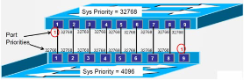

# **Spanning Tree Protocol (STP)**

* STP Operation
  + Elect a root bridge
  + Select the root port on all non-root bridges
  + Select the designated port on each segment

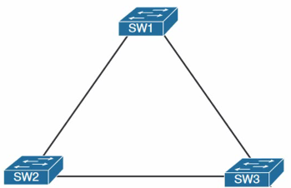

* STP Protocol Frames
  + STP uses Bridge Protocol Data Units (BPDUs), also known as configuration messages, as its protocol frames
  + STP-enabled devices exchange BPDUs to establish a spanning tree. BPDUs contain sufficient information for the devices to complete spanning tree calculation.
  + STP uses two types of BPDUs, configuration BPDUs and Topology Change Notification (TCN) BPDUs.
  + Configuration BPDU
    - The payload of a configuration BPDU includes the following fields:
      * Protocol ID- Fixed at 0x0000, which represents IEEE 802.1d
      * Protocol version ID- Spanning tree protocol version ID. The protocol version ID for STP is 0x00
      * BPDU type- Type of the BPDU. The value is 0x00 for a configuration BPDU
      * Flags- An 8-big field indicates the purpose of the BPDU. The lowest bit is the Topology Change (TC) flag. The highest bit is the Topology Change Acknowledge (TCA) flag. All other bits are reserved.
      * Root ID- Root bridge ID formed by the priority and MAC address of the root bridge.
      * Root path cost- Cost of the path to the root bridge
      * Bridge ID- Designated bridge ID formed by the priority and MAC address of the designated bridge
      * Port ID- Designated port ID formed by the priority and global port number of the designated port
      * Message age- Age of the configuration BPDU while it propagates in the network
      * Max age- Maximum age of the configuration BPDU stored on the switch
      * Hello time- Configuration BPDU transmission interval (2s)
      * Forward delay- Delay for STP bridge to transit port state (15s)
    - Switch uses the above information for Spanning tree calculation
  + TCN BPDU
    - Switches use TCN BPDUs to announce changes in the network topology
    - The payload of a TCN BPDU includes the following fields:
      * Protocol ID- Fixed at 0x0000, which represents IEEE 802.1d
      * Protocol version ID- Spanning tree protocol version ID. The protocol version ID for STP is 0x00
      * BPDU type- Type of the BPDU. The value is 0x80 for a TCN BPDU
    - A non-root bridge sends TCN BPDUs when one of the following events occurs on the bridge:
      * A port transits to the forwarding state, and the bridge has a minimum of one designated port
      * A port transits from the forwarding or learning state to the blocking state
  + What does the Root Bridge do when receiving a TCN?
    - Sets “TC-Flag” when transmitting BPDUs into that VLAN
    - Those BPDUs are now called Topology Change BPDUs
    - Continues transmitting TC-BPDUs for Forwarding-Delay + Max-Age (35-sec)
    - Reduces its own CAM Aging time to Forwarding Delay for the affected VLAN
  + What does the Non-Root Bridges do when receiving a TCN-BPDU?
    - Reduce CAM Aging Time=Forwarding-Delay
    - Any Mac addresses within affected VLAN not heard from during this time are flushed from CAM/MAC Address-Table.
* Root Bridge Election
  + Switch with lowest Bridge ID in the network becomes Root Bridge
  + Bridge ID contains:
    - Bridge Priority
      * 0 – 61440 in increments of 4096
    - System ID Extension
      * 0 – 4095 (VLAN number)
    - MAC Address
* Changing the Root Bridge Election
  + Manually change BID priority
    - Spanning-tree vlan x priority
    - Lower is better
  + Use root bridge macro
    - Spanning-tree vlan x root [ primary | secondary]
    - Sets local priority based on current Root Bridge
  + Verification
    - Show spanning-tree vlan x
    - Show spanning-tree root
* Root Port Election
  + Root port is upstream facing towards Root Bridge
  + Election based on lowest Root Path Cost
    - Cumulative cost of all links to get to the root
  + Cost based on inverse bandwidth
    - Higher bandwidth, lower cost
      * Not linear
  + If tie in cost then:
    - Choose lowest upstream BID
    - Choose lowest upstream Port ID

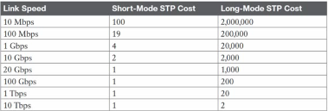

* Designated Port Election
  + Designated ports are downstream facing away from Root Bridge
  + Like Root Port, elected based on:
    - Lowest Root Path Cost
    - Lowest BID
    - Lowest Port ID
  + All other ports go into blocking mode
    - Receive BPDUs
    - Discard all other traffic
    - Cannot send traffic
* Modifying Path Selection (by changing the Port’s Role)
  + Modify the port’s cost
    - Spanning-tree vlan x cost
    - Bandwidth [bps]
  + Modify the Bridge ID
    - Spanning-tree vlan x priority
  + Modify Port ID
    - Spanning-tree vlan x port-priority
  + Verification
    - Show spanning-tree interface [int] detail
    - Show spanning-tree vlan x detail

# **Spanning-Tree Enhancements (Optional Features)**

* Spanning-Tree Optional features
  + STP Convergence Optimization
    - PortFast
    - UplinkFask
    - BackboneFast
  + STP Filters
    - BPDU Filter
    - BPDU Guard
    - Root Guard
  + STP Loop Prevention
    - Loop Guard
    - UDLD
* STP Convergence Optimization (Legacy STP)
  + PortFast
    - Edge ports shouldn’t be subject to Forwarding Delay
    - Also effect TCN generation
    - Methods for configuration:
      * [int]] spanning-tree portfast
      * [Global] spanning-tree portfast default
    - Macro command
      * [int] switchport host
        + This command will set switchport mode to Access, enable spanning-tree portfast, and disable channel group.
  + UplinkFast
    - Direct Root Port failure should reconverge immediately
    - Transition blocked port immediately to Root upon physical loss of primary Root Port
    - Enable for entire switch on all VLANs
    - How it operates?
      * By generating Dummy Multicast on behalf of connected hosts
    - Only meant to be implemented on Access-Layer Switches
    - How to configure it?
      * Spanning-tree uplinkfast (Globally on switch)
  + BackboneFast
    - Indirect failures should start recalculating immediately
    - Used to detect indirect link failures
      * Watches for inferior BPDUs from Designated Bridges
      * Use of RLQs (Root Link Queries)
    - How to configure it?
      * Spanning-tree backbonefast (Globally on switch)
* Spanning-Tree Filters
  + BPDU Filter (on Access switch)
    - Filters BPDU in and out
  + BPDU Guard (on Access switch)
    - If BPDU is received shut port down
  + Root Guard (on Distribution/Core switch)
    - If superior BPDU is received shut port down
* Spanning-Tree Loop Prevention
  + STP Loop Guard (must be enabled on all trunk ports, specially fiber ports)
    - Prevent unidirectional links by using BPDU keepalives
  + Unidirectional Link Detection (UDLD)
    - Prevent unidirectional links by using UDLD keepalives

# **Rapid Spanning-Tree Protocol (RSTP – RPVST)**

* What is Rapid Spanning-Tree Protocol?
  + New standard originally defined in IEEE 802.1w
  + Now incorporated as IEEE 802.1D-2004
* RSTP versus legacy STP
  + Simplifies port states
  + Additional port roles
  + Rapid convergence based on synchronization process
  + Path calculation remains the same
* RSTP Port States
  + Legacy STP uses:
    - Disabled
    - Blocked
    - Listening
    - Learning
    - Forwarding
  + RSTP simplifies to:
    - Discarding
      * Dropping frames
    - Learning
      * Dropping frames but building the CAM table
    - Forwarding
      * Normal forwarding

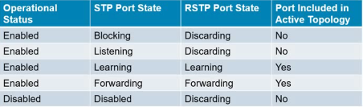

* RSTP Port Roles
  + Port Roles are decoupled from port states
  + Root Port & Designated Port
    - Same as before
  + New Roles
    - Alternate
    - Backup
    - Edge
* RSTP Alternate ports
  + Alternate but less desirable path to the root
  + Allows the equivalent of UplinkFast
* RSTP Backup Ports
  + Backup Designated Port
  + Active if the primary designated port fails
  + Operates in Discarding state
* RSTP Edge Ports
  + Equivalents of PVST+ PortFast enabled ports
    - Immediately transitions to forwarding
    - Do not generate TCN for state change
    - Configured with spanning-tree portfast command for backwards compatibility
  + Maintains edge status as long as no BPDUs are received
    - If BPDU received, remove edge status and generate TCN
* RSTP Link Types
  + Non-edge ports fall into two types
    - Point-to-Point
      * Full-Duplex ports
    - Shared
      * Half-Duplex ports
  + Only Point-to-Point Designated ports use the sync process for rapid convergence
* RSTP Operation (Sync Process)
  + Goal is for bridge to synchronize its root port with the rest of the topology
  + When a bridge elects a root port, it assumes all non-edge ports to be designated
    - All non-edge ports are discarding at this moment
  + Bridge sends proposals out all designated ports
    - Proposal has port role set to designated
    - Proposal contains root bridge info (priority, cost, and …)
  + Downstream bridges review this information
    - If they don’t have better path to the root they agree
    - If they do have it they announce their information
  + When designated port receive agreement, it is unblocked
  + If downstream bridge sends better root information, local bridge changes root port
  + If downstream bridge agree to upstream proposal, then it:
    - Elect a local root port
    - Blocks all non-edge designated ports
    - Starts sync process on all designated ports
  + Ports blocking is essential in preventing transient loops
  + Sync process ensures all bridges agree on the same root bridge

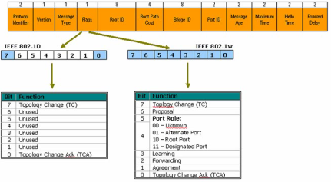

* RSTP Fault Detection
  + In legacy STP, BPDUs are only generated by Root Bridge
    - All other bridges forward them on
  + In RSTP, each bridge generates BPDU every hello interval
    - Hello interval is 2 seconds by default
  + If 3 hellos are missed from a neighbor, convergence begins
    - It takes 6 seconds vs. 20 seconds MaxAge(on Legacy)
  + MaxAge is used as hop count
    - Every bridge sends BPDUs on its own
    - Age incremented by every bridge
    - MaxAge also used on shared ports for legacy STP backwards compatibility
  + Fault can be detected faster by means of physical layer signaling
* RSTP Convergence
  + RSTP needs to re-converge when Root port is lost
  + If there is an Alternate port, it is selected in place of old Root port
    - New Root port is then synchronized with downstream bridges
  + If there are no alternate ports and no better info:
    - Declare itself as root
    - Synchronized this decision
    - Possibly adapt to better information
  + Non-deterministic, depends on topology
    - Meshy and large topologies converge slow
  + To ensure fast convergence:
    - Keep topology small and avoid excessive redundancy
    - Rely on physical layer failure detection not the Hello BPDUs
* RSTP Topology Change
  + Generated when link becomes forwarding
    - Originated by the switch that detected the event
    - Uses special BPDU bit to signal topology change
    - Flooded by all switches using reverse path forwarding
  + Flushes MAC address tables
    - Causes temporary excessive unicast traffic flooding
    - Use Edge ports as much as possible
* RSTP Configuration
  + Enable RSTP
    - Spanning-tree mode rapid-pvst
    - Automatically backwards compatible with legacy STP
  + Sync only occurs on P2P non-edge ports
    - Implies link-type must be accurate
    - Spanning-tree link-type [point-to-poin
    - Spanning-tree portfast [trunk]
  + Path selection remains unchanged
    - Root bridge election
    - Root port & designated port elections

# **Multiple Spanning-Tree (MST)**

* Started as Cisco’s MISTP
* Originally defined in IEEE 802.1s
* Now standard per IEEE 802.1Q-2005
* How does MST work?
  + MST works by decoupling VLAN & STP Instance
    - STP instance to VLAN mapping is user defined
    - Topology calculation done by RSTP
  + Result is higher scalability
    - (Rapid) PVST+ uses one instance per VLAN
    - As VLANs scale, control plane dies
    - PVST is inefficient because there are typically only 3 possible tree anyways
* MST Regions
  + MST defines a Region as bridges that agree upon:
    - Instance name
    - Revision number
    - VLAN to STP instance mappings

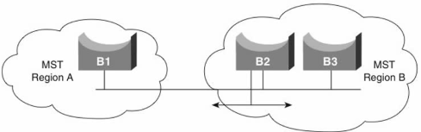

* MST Regions (Intra vs. Inter Region)
  + Intra Region
    - Details of the region are known within the region
    - VLAN to STPIs are manually defined
    - Undefined VLANs fall into CIST (MST 0)
  + Intra Region
    - Details between regions are not known
    - Different regions see each other as virtual bridge
    - Result is simplified Inter-Region calculation
    - Intra-region MSTIs are collapsed into CIST
* MST Interoperability
  + MST is backward compatible with legacy CST and PVST+
  + Behaves like Inter-Region MST
  + CST Root must be within MST
* MST configuration
  + Define the following in MST configuration mode
    - Region name
    - Revision number
    - VLAN to instance mappings
  + Enable MST globally
    - Real deployment must start at root and work out
* MST Path Selection
  + Same election process as CST/PVST
* Changing MST Root Bridge Election
  + Manually change BID priority
    - Spanning-tree mst [instance] priority
    - Lower is better
  + Use root bridge macro
    - Spanning-tree mst [instance] on current Root bridge
    - Sets local priority based on current Root bridge
  + Verification
    - Show spanning-tree mst [instance]
    - Show spanning-tree root
* MST port’s Role modification
  + Modify the port’s cost
    - Spanning-tree mst [instance] cost
    - Bandwidth [bps]
  + Modify the Bridge ID
    - Spanning-tree mst [instance] priority
  + Modify the Port ID
    - Spanning-tree mst [instance] port-priority
  + Verification
    - Show spanning-tree interface [int] detail
    - Show spanning-tree mst [instance] detail

# **CEF-Based Multilayer Switching (Multilayer Switching and Cisco Express Forwarding)**

* Switching (L2 vs. L3)
  + Layer 2 Switching:
    - Based on MAC Address only
    - The only frames destined for the switch’s local MAC addresses are L2 Management frames
      * STP
      * DTP
      * CDP & …
  + Layer 3 Switching
    - Based on L2 and L3 headers
    - Switch contains L3 Routing Processor (RP)
    - Frames can be received, destined for MAC of RP
* Multilayer Switch Processing
  + Combines functionality of switch and router
  + Offloads software-based routing process (packet rewrite) to specialized ASIC
  + Provides write-speed Ethernet routing and switching services
  + Optimized for campus LAN
* Frame Rewrite
  + The incoming frame checksum is verified to ensure that no frame corruption or alteration occurs during transit
  + The incoming IP header checksum is verified to ensure that no packet corruption or alteration occurs during transit
* High-Speed Memory Tables
  + Multilayer switches build routing, bridging, QoS, and ACL tables for centralized or distributed switching
  + Switches perform lookups in these tables to make decisions, such as to determine whether a packet with a specific destination IP address is supposed to be dropped according to ACL
  + These tables support high-performance lookups and search algorithms to maintain line-rate performance
  + Multilayer switches deploy these memory tables using specialized memory architectures, referred to as Content Addressable memory (CAM), and Ternary Content Addressable Memory (TCAM)
* CAM Table
  + Matches based on two values: 0 or 1
  + Useful for building tables that search on exact matches such as MAC address tables
  + Primary table used to make Layer 2 forwarding decisions
  + Built by recording the source MAC address and inbound port of all incoming frames.
* TCAM Table
  + Matches based on three values: 0, 1, or x (where x is either number also called don’t care)
  + TCAM is most useful for building tables for searching on the longest match, such as IP routing tables organized by IP prefixes
  + The memory structure is broken into a series of patterns and associated masks
  + Stores ACL, QoS, and other information generally associated with Layer 3 and higher processing

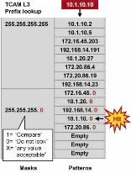

* Cisco Switching Methods
  + Process Switching
    - Process switching is the most CPU-intensive method available in Cisco routers. It can greatly degrade performance and is generally used only as a last resort or during troubleshooting
  + Fast Switching
    - After the lookup of the first packet destined for a particular IP network, the router initializes the fast-switching cache used by the fast switching mode. When subsequent frames arrive, the destination is found in this fast-switching cache.
  + Cisco Express Forwarding (CEF)
    - The default-switching mode. CEF is less CPU-intensive than fast switching or process switching. A router with CEF enabled uses information from tables built by the CPU, such as the routing table and ARP table, to build hardware-based tables known as the Forwarding Information Base (FIB) and Adjacency tables.
* Forwarding Information Base
  + CEF Components (FIB)
    - Forwarding Information Base
    - Copy of IP Routing Table
  + Verification Commands
    - Show ip cef [default]
    - Show ip cef <ip-addr> <mask> detail

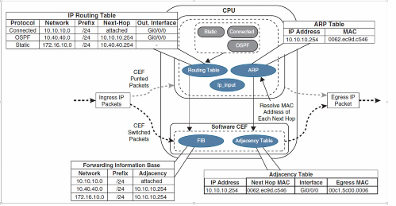

* Adjacency Table
  + CEF Components (Adjacency Table)
    - Populated with L2 adjacency information
    - Populated by L2 tables such as:
      * ARP Table
      * Frame-Relay Mapping Table
  + Verification Commands:
    - Show adjacency <int type/number> [summary | detail]
    - Show adjacency vlan <vlan-id> detail
* Adjacency Types
  + Some adjacency types can’t be CEF switched and must be dropped, or sent to CPU for processing:
    - Glean
    - Null
    - Drop
    - Discard
    - Punt
* Adjacency Types
* CEF on Multilayer Switches
  + CEF is enabled by default on Multilayer Switches
  + Because switches have specialized hardware ASICS and memory, CEF cannot be disabled
* Non-CEF-Switched Packets
  + Some packets on switches can’t be CEF-switched:
    - ARP Requests
    - Packets requiring responses from router CPU
    - Routing Protocol Traffic
    - CDP
    - Packets needing encryption
  + Verification commands:
    - Show cef drop

# **Switching Operation (L2, L3 Forwarding)**

* Multilayer Switch Primary Components
  + Switch Processor:
    - Switching Processor
    - Routing Processor
  + ASICs:
    - Application-Specific Integrated Circuit
  + Switch Fabric
  + Memory
    - Flash, DRAM, NVRAM, CAM, TCAM, SRAM
* Forwarding Engines
  + Forwarding Engine
    - ASIC(s) responsible for looking up frames/packets
    - Some switches have more than one forwarding engine
      * Centralized switching
      * Distributed switching
* Manipulation and Control of TCAMs
  + SDM (Switching Database Manager)
    - Allows tuning of shared TCAM partitions
    - Only available on some switches (Cat3750s, 3550s)
    - Show status command:
      * # show sdm prefer
    - Manipulate SDM commands
      * #Sdm prefer routing
      * #end
      * #reload

# **Routing (IP Routing Essentials)**

* A router’s primary function is to move an IP packet from one network to a different network
* A router can be made aware of remote networks in two types:
  + An administrator can manually configure the information (static routing)
  + The router can learn from other routers (dynamic routing)
* A routing table can contain both static and dynamically recognized routings
* Static Routes
  + A static route can be used in the following circumstances:
    - To have absolute control of routes used by the router
    - When a backup to a dynamically recognized route is necessary
    - When it is desirable to have dynamic routing updates forwarded across slow bandwidth links
    - To reach a stub network
  + Static routes provide precise control over routing but may create an administrative burden as the number of routers and network segments grow
  + Because the routers are not communicating, there is no network intelligence. If a link goes down, other routers will not be aware that the network path is no longer valid
  + Static route types:
    - Directly attached static routes
    - Recursive static route
    - Fully specified static route
  + Directly attached static routes
    - Do not have to worry about maintaining an adjacency table and do not use ARP. E.g. Point-to-Point (P2P) serial interfaces
    - Static routes can directly reference the outbound interface of a router
    - A static route that uses only the outbound next-hop interface is known as a directly attached static route, and it requires that the outbound interface be in an up state for the route to be installed into the RIB

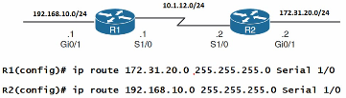

* + Recursive static routes
    - The forwarding engine on Cisco devices needs to know which interface an outbound packet should rate
    - A recursive static route specifies the IP address of the next-hop address
    - The recursive lookup occurs when the router queries the RIB to locate the route toward the next-hop IP address (connected, static, or dynamic) and then cross-references the adjacency table

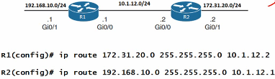

* + Fully Specified Static Routes
    - When a link fails, static route recursion can simplify topologies by allowing the static route to stay installed while it changes to a different outbound interface in the same direction as the destination
    - A static route with both an interface and a next-hop IP address is known as a fully specified static route
      * If the interface listed is not in an up state, the router removes the static route from the RIB
        + Specifying the next-hop address along with the physical interface removes the recursive lookup and does not involve the ARP processing problems that occur when using only the outbound interface



* + Floating Static Routes
    - Static route can be configured with an AD value of 1 to 255 for a specific route
    - Using a floating static route is a common technique for providing backup connectivity for prefixes learned via dynamic routing protocols
    - A floating static route is configured with an AD higher than that of primary route
      * Because the AD is higher than that of the primary route, it is installed in the RIB only when the primary route is withdrawn

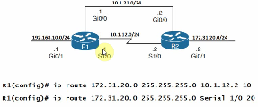

I’m on 6_2 on Min 24 on Static Null Routes

# **Autonomous System (AS)**

* AS numbers can be between 1 to 65,535
  + RIRs (Regional Internet Registries) manage the AS numbers between 1 and 64,512
  + The 64,512 – 65,535 numbers are reserved for private use (similar to IP Private addresses)
  + According to RFCs 4893 and 5398, As numbers has been extended to 4,294,967,296

# **BGP Basics**

* BGP is a path vector protocol
* It is the only routing protocol to use TCP
  + OSPF and EIGRP reside directly above the IP layer, IS-IS is at the network layer
  + RIP uses the UDP for its transport layer
* BGP version 4 (BGP-4) is the latest version of BGP
  + Defined in RFC 4271
  + Supports supernetting (CIDR) and VLSM
* BGP4 and CIDR prevent the Internet routing table from becoming too large
  + Without CIDR, the Internet would have 2,000,000+ entries
  + With CIDR, internet core routers manage around 492000 entries
* To view BGP routing table or worldwide core routers:
  + <http://bgp.potaroo.net/>
  + <http://bgpupdates.potaroo.net/instability/bgpupd.html>
* BGP vs. IGPs
  + BGP works differently than IGPs because it does not make routing decisions based on best path metrics
    - Instead, BGP is a policy-based routing protocol that allows an AS to control traffic flow using multiple BGP attributes
  + BGP allows an organization to fully use all of its bandwidth by manipulating these path attributes

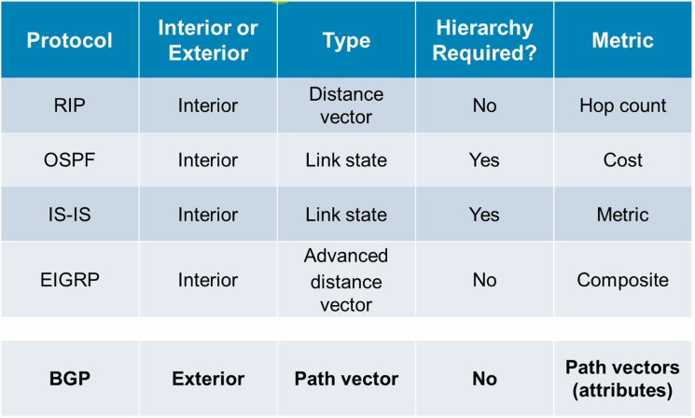

# **Using BGP**

* BGP can be used to dynamically exchange routing information
* BGP can also be configured to react to topology changes beyond a customer-to-ISP link

# **Using BGP in an Enterprise Network**

* When BGP is running between routers in different AS, it is called **External BGP (EBGP)**.
* When BGP is running between routers in the same AS, it is called **Internal BGP (IBGP)**.

# **External BGP (EBGP)**

* EBGP neighbors are in different autonomous systems
  + EBGP neighbors need to be directly connected

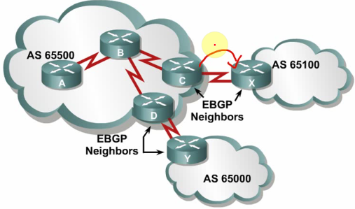

# **General Notes**

* Each router can only have 1 BGP instance.
* To view BGP neighbor table:
  + Show ip bgp summary
  + Show ip bgp neighbors
* To view BGP routing table or BGP topology table:
  + Show ip bgp
* AD of EBGP routes is 20, AD of IBGP is 200
* In order to set BGP advertising interface:
  + Neighbor [neighbor-ip] update-source [local loopback]
* BGP sends some NLRI (Network Layer Reachability Information) packets
* When in EBGP, neighbor is more than 1 hop away, we should use the following format to mention the multi-hop distance:
  + Neighbor [neighbor ip] ebgp-multihop [maximum hop count](1-255)
* BGP route refresh, in order to resend the routing parameters in ingoing/outgoing direction:
  + Clear ip BGP * (in/out)

# **IBGP Neighbors Relationship requirements**

* Define neighbors
  + A TCP session(3-way handshake) must be established before starting BGP routing update exchanges
* Reachability
  + IBGP neighbors must be reachable usually by using an IGP (OSPF, EIGRP, IS-IS, RIP, etc.); In case of Service Provider, mostly OSPF and IS-IS are used.
  + Loopback IP addresses are typically used to identify IBGP neighbors.
* Same AS Number
  + IBGP neighbors must have the same AS number

# **IBGP in a Transit AS**

* A Transit AS is an AS that routes traffic from one external AS to another external AS
  + Transit AS networks are typically ISPs
* Routers in a transit autonomous system must have Full-Mesh connection

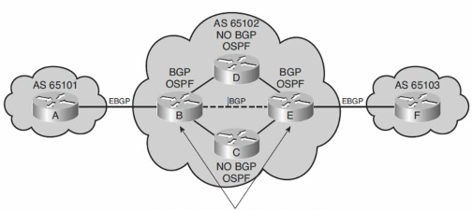

# **IBGP in a Non-Transit AS**

* A Non-Transit AS is an AS that does not route traffic from one external AS to another external AS
  + Non-transit AS networks are typically enterprise networks
* All routers in a non-transit autonomous system must still have full knowledge of external routes
* To avoid routing loops within an AS, BGP specifies that routes learned through IBGP are never propagated to other BGP peers
  + It is assumed that the sending IBGP neighbor is fully meshed with all other IBGP speakers and has sent each BGP neighbor the update
* **Three multi-homing connection options**

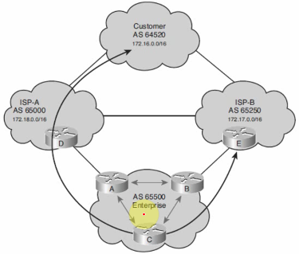

* + Each ISP passes only a default route to the AS
    - The default route is passed on to internal routers
  + Each ISP passes only a default route and provider-owned specific routes to the AS
    - These routes may be propagated to internal routers, or all internal routers in the transit path can run BGP to exchange these routes
  + Each ISP passes all routes to the AS
    - All internal routers in the transit path run BGP to exchange these routes

# **BGP Messages**

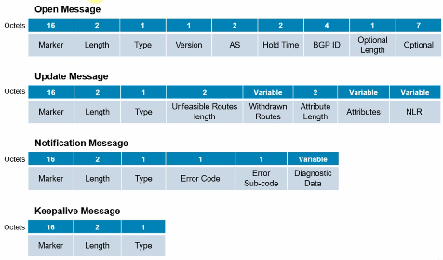

* All messages begin with the same 3 field headers (Marker, Length, Type)
* **Open Message**
  + Once a TCP connection has been established, the Open Message is sent and includes a set of parameters that have to be agreed upon before a full BGP adjacency can be established.
  + Once both BGP peers have agreed upon mutual capabilities, they can start exchanging routing information by means of BGP update messages
* **Update Message**
  + An update message includes the following information:
    - Unreachable routes information
    - Path attribute information
    - Network-Layer Reachability Information (NLRI)
  + NLRI format
    - NLRI is a list of <length, prefix> tuples
      * One tuple for each reachable destination
      * The prefix represents the reachable destination
      * The prefix length represents the # of bits sent in the subnet mask

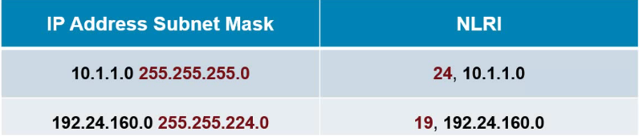

* **Notification Message**
  + A BGP notification message is sent when an error condition is detected
    - The BGP connection is closed immediately after this is sent
  + Notification messages include an error code, an error subcode, and data related to the error.
* **Keepalive Message**
  + Keepalive messages are sent between peers every **60 seconds** (by default) to maintain connection.
  + The message consists of only a message header (19 bytes)
    - Hold time is three times the KEEPALIVE timer of 60 seconds
    - If the periodic timer = 0, no keepalives is sent.
    - Recommended keepalive interval is one-third of the hold time interval

# **BGP Path Attributes**

* A BGP update message includes a variable-length sequence of path attributes describing the route
* A path attribute consists of three fields:
  + Attribute type
  + Attribute length
  + Attribute value

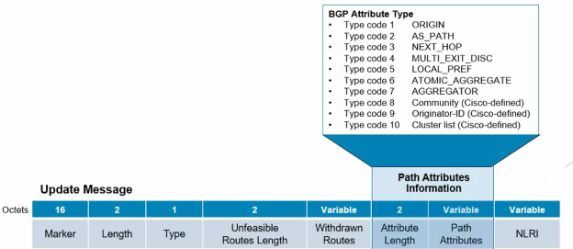

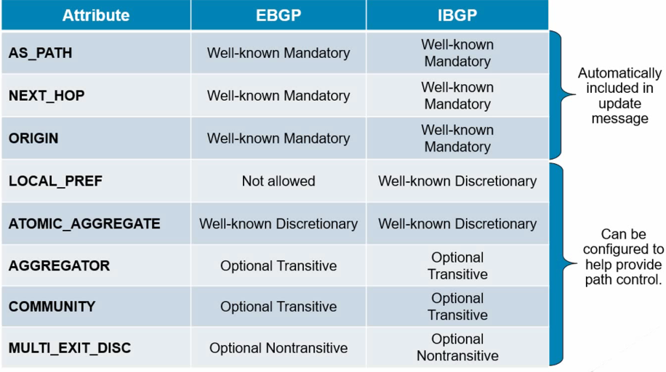

# **BGP Route Selection Process**

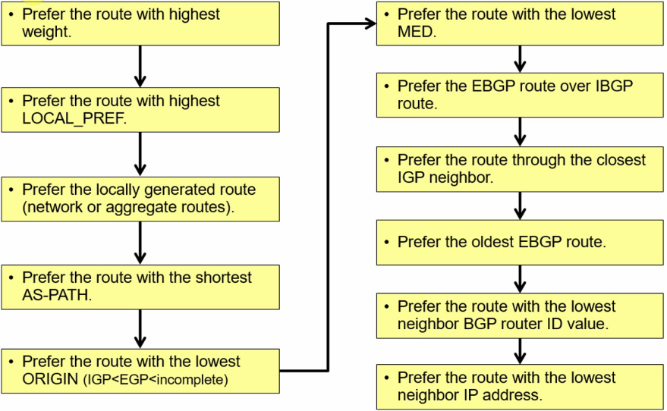

* Default weight is 1
* Default LOCAL_PREF is 100
* Inbound attributes:
  + Weight
  + LOCAL_PREF
* Outbound attributes:
  + AS Path
  + Metric
  + Etc.

# **Address Family in BGP**

* There are two forms of Address family:
  + AFI
  + SFI
* In order to apply different AFIs and SFIs to different neighbors, 2 templates should be built for neighbors:
  + 1 Template For creating Sessions (peer-session)
  + 1 Template for applying policies (peer-policy)
* These templates are used on Route Reflector routers
* Here is the configuration required in the Lab Scenario "BGP Route Reflector" available on the LAB files:
  + router bgp 5500
  + template peer-policy IPV4_RR_CLIENTS
  + route-reflector-client
  + next-hop-self
  + exit-peer-policy
  + !
  + template peer-session PEER_CLIENTS
  + remote-as 5500
  + update-source Loopback1
  + exit-peer-session
  + !
  + bgp log-neighbor-changes
  + no bgp default ipv4-unicast
  + neighbor 2.2.2.2 inherit peer-session PEER_CLIENTS
  + neighbor 3.3.3.3 inherit peer-session PEER_CLIENTS
  + neighbor 4.4.4.4 remote-as 5500
  + neighbor 4.4.4.4 inherit peer-session PEER_CLIENTS
  + neighbor 4.4.4.4 update-source Loopback1
  + neighbor 10.1.16.6 remote-as 6
  + !
  + address-family ipv4
  + neighbor 2.2.2.2 activate
  + neighbor 2.2.2.2 inherit peer-policy IPV4_RR_CLIENTS
  + neighbor 3.3.3.3 activate
  + neighbor 3.3.3.3 inherit peer-policy IPV4_RR_CLIENTS
  + neighbor 4.4.4.4 activate
  + neighbor 4.4.4.4 inherit peer-policy IPV4_RR_CLIENTS
  + neighbor 10.1.16.6 activate
  + exit-address-family

# **AS Prepend in BGP**

* A mechanism for increasing AS Path attribute of BGP routing protocol in order to manipulate the traffic path
* An example of the required steps in the "AS Route Reflector" Scenario:
  + Ip prefix-list six permit 6.6.6.6/32
  + Route-map x permit 20
    - Match ip address prefix-list six
    - Set as-path prepend 5500 5500 5500 5500

# **BGP Confederation**

* In order to run BGP Confederation between two sub-AS inside another AS the following commands are used inside "BGP Confederation" Scenario:
  + router bgp 65100
    - bgp log-neighbor-changes
    - bgp confederation identifier 200
    - bgp confederation peers 65200
    - neighbor 10.1.25.5 remote-as 65200

# **IPv6**

* IPv4 Header is 20 Bytes, but IPv6 Header is 40 Byte. IPv4 is 32bit, but IPv6 is 128bit.
* IPv6 Features:
  + Elimination of public-to-private NAT
    - End-to-end communication trace is possible
  + Elimination of Broadcast addresses
    - IPv6 now includes unicast, multicast, and anycast addresses

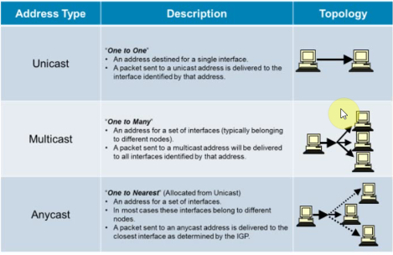

* **IPv4 vs. IPv6 Header**

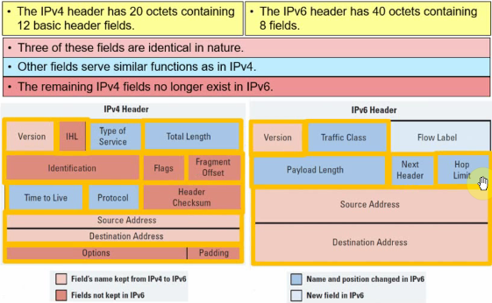

* **Protocol and Next Header Fields**
  + In IPv4 the Protocol field is used to identify the next level protocol (e.g. TCP, UDP, ICMP, …)
  + In IPv6 this field is called the "Next Header" field and serves the same purpose.
* **Extension Headers**
  + The Next Header field identifies what follows the Destination Address field:
    - Protocols:
      * TCP (Protocol 6)
      * UDP (Protocol 17)
      * ICMPv6 (Protocol 58)
    - Extension Header
  + Extension headers make the handling of options more efficient

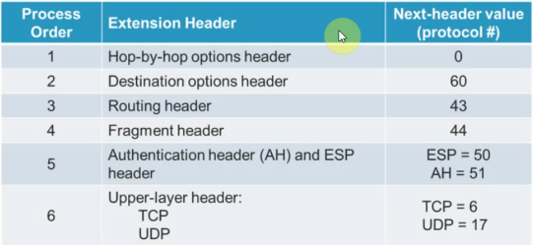

* **MTU Discovery**
  + IPv6 routers no longer perform fragmentation
  + A discovery process is used to determine the optimum MTU to use during a given session
    - In this discovery process, the source device attempts to send a packet at the size that is specified by the upper IP layer, for example, the transport and application layers.
  + If the device receives an ICMP "packet too big" message, it retransmits the MTU discover packet with a smaller MTU; This process is repeated until the device receives a response that the discover packet arrived intact.
  + The device then sets the MTU for the session.
* **New IPv6 Features**
  + Prefix renumbering
    - IPv6 allows simplified mechanisms for address and prefix renumbering
  + Multiple addresses per interface
  + Link-local addresses
    - IPv6 link-local addresses are used as the next hop when IGPs are exchanging routing updates
  + Stateless autoconfiguration
    - DHCP is not required because an IPv6 device can automatically assign itself a unique IPv6 Link-local address
  + Provider-dependent or provider-independent addressing
* **IPv4 & IPv6 Coexistence**
  + Dual stack
    - Both IPv4 and IPv6 are configured and run simultaneously on the interface
  + IPv6-to-IPv4 (6to4) tunneling and IPv4-compatible tunneling
  + NAT protocol translation (NAT-PT) between IPv6 and IPv4
* **IPv6 Address Allocation Process**
  + the following displays how IPv6 global unicast addresses are allocated by the IANA.
    - Only a small portion (12.5%) of the IPv6 address space is being allocated to the registries in the range of 2001::/16

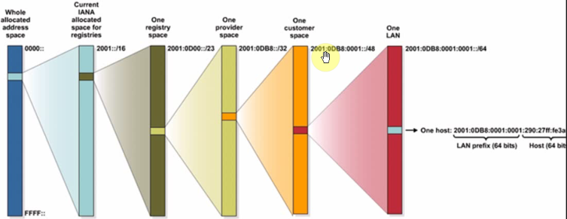

* **IPv6 Address Specifics**
* The 128-bit IPv6 address is written using hexadecimal numbers
  + Specifically, it consists of 8, 16-bit segments separated with colons between each set of four hex digits (16 bits)
  + Referred to as "coloned hex" format
  + Hex digits are not case sensitive
  + The format is x : x : x : x : x : x : x : x , where x is a 16-bit hexadecimal field therefore each x is representing four hexadecimal digits
* An example address is as follows:
  + 2035:0001:2BC5:0000:0000:087C:0000:000A
* **Abbreviating IPv6 Addresses**
  + Leading 0s within each set of four hexadecimal digits can be omitted:
    - 09c0 = 9c0
    - 0000 = 0
* **IPv6 Addressing in an Enterprise Network**
  + An IPv6 consists of two parts:
    - A subnet prefix representing the network to which the interface is connected
      * Usually 64-bits in length
    - An interface ID, sometimes called a local identifier or a token
      * Usually 64-bits in length

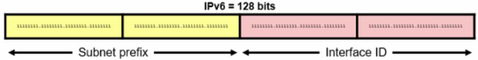

* **Subnet prefix**
  + IPv6 uses the "/prefix-length" CIDR notation to denote how many bits in the IPv6 address represent the subnet.
  + The syntax is *ipv6-address/prefix-length*
    - *Ipv6-address* is the 128-bit IPv6 address
    - */prefix-length* is a decimal value representing how many of the left most contiguous bits of the address comprise the prefix
  + For example:
    - Fec0:0:0:1::1234/64 is really
      * Fec0:0000:0000:0001:0000:0000:0000:1234/64
        + The first 64-bits (Fec0:0000:0000:0001) forms the address prefix
        + The last 64-bits (0000:0000:0000:1234) forms the Interface ID
* Note: Viewing MAC address of an interface:
  + E.g. Sh int e0/0 | i bia
* **Interface Identifiers**
  + IPv6 addresses on a link must be unique
  + Because the prefix length is fixed and well-known (64-bits), IPv6 hosts can automatically create a unique IPv6 address
  + For example, the following layer 2 protocols can automatically create the IPv6 address interface ID:
    - Ethernet (using the EUI-64 format)
    - PPP
    - HDLC
    - NBMA, Frame Relay
* **Special IPv6 Addresses**

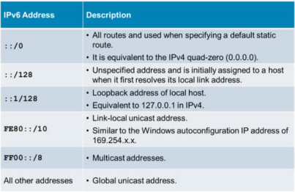

* **IPv6 Address Scopes**
  + Address types have well-defined destination scopes:
    - Link-local address
    - Global unicast address

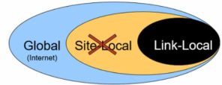

* **IPv6 Link-local address**
  + Link-local addresses are used for automatic address configuration, neighbor discovery, router discovery, and by many routing protocols
  + They are automatically created using a link-local prefix of FE80::/10 and a 64 bit interface identifier:
    - Unique only on the link, and it is not routable off the link.

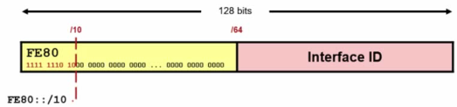

* + When pinging the other device's link-local, the source interface must be specified
* **IPv6 Global Unicast Address**
  + A global unicast address is an IPv6 address from the global public unicast prefix (2001::/16)
  + Global unicast addresses are aggregated upward through organizations and eventually to the ISPs
  + The global unicast address typically consists of:
    - A 48-bit global routing prefix
    - A 16-bit subnet ID
    - A 64-bit interface ID (typically in EUI-64 bit format)

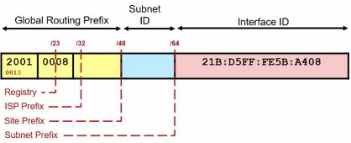

* **IPv6 Multicast Address**
  + Multicasting is at the core of many IPv6 functions and it is a replacement for the broadcast address
  + They are defined by the prefix FF00: : / 8
    - An interface may belong to any number of multicast groups

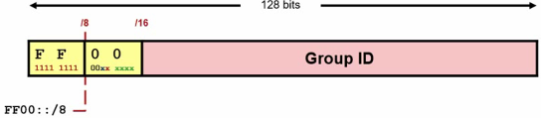

* + The second octet of the address contains the prefix and transient (lifetime) flags, and the scope of the multicast address

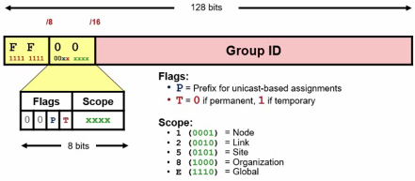

* + IPv6 Multicast groups are as follows:

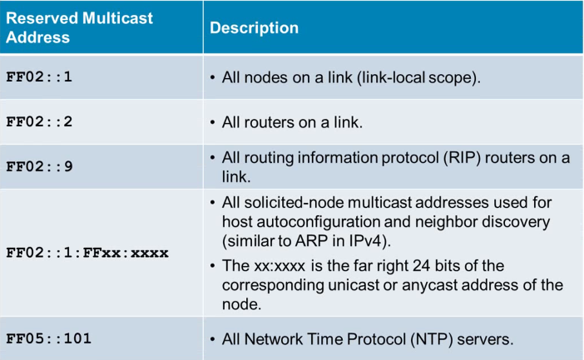

# **IPv6 Routing**

* IPv6 supports the following routing
  + Static routing
  + RIPng
  + OSPFv3
  + IS-IS for IPv6
  + EIGRP for IPv6
  + Multiprotocol BGP version 4 (MP-BGPv4)
* **Static Routing**
  + There is an IPv6-specific requirement per RFC 2461
    - A router must be able to determine the link-local address of each of its neighboring routers to ensure that the target address of a redirect message identifies the neighbor router by its link-local address
    - This requirement basically means that using a global unicast address as a next-hop address with routing is not recommended because link-local address is all that is needed, and the “global unicast address” network prefix could change
  + Directly attached IPv6 static route
    - E.g.: ipv6 route 2001:CC1E::/32 serial 0/0/0
  + Recursive static route
    - E.g.: ipv6 route 2001:CC1E::/32 2001:12::1
  + Fully specified static route
    - Includes both the outgoing interface and the next hop address
    - Used on multiaccess interfaces (Ethernet) with multiple devices
    - E.g.: ipv6 route 2001:CC1E::/32 serial 0/0/0 2001:12::1
  + Floating static route
    - The route is set with the administrative distance value higher than the administrative distance of any IGP to reach a particular destination
    - The static route functions as a backup IGP discovered route
      * It will only be added to the routing table if the IGP entry is deleted
* **RIPng**
  + Routing Information Protocol next generation (RIPng, RFC 2080) is a distance vector routing protocol for IPv6
    - It is based on IPv4 RIP version 2 (RIPv2)
  + It is similar to RIPv2 because:
    - The hop limit is still 15
    - The administrative distance is still 120
    - It still uses split horizon and poison reverse to prevent routing loops
  + Unlike RIPv2, RIPng is:
    - Used to transport IPv6 networks and prefixes
    - Uses UDP port 520 (instead of UDP port 521)
    - Uses the multicast group FF02::9 (instead of 224.0.0.9)

# **OSFPv3**

* The protocol implementation for IPv6 include these characteristics:
  + Based on OSPFv2 with enhancements
  + Distributes IPv6 prefixes
  + Runs directly over IPv6
* This implementation adds these IPv6-specific attributes:
  + 128-bit addresses
  + Link-local address
  + Multiple addresses and instances per interface
  + Authentication (now uses IPsec)
  + OSPFv3 runs over a link rather than a subnet
* OSPFv3 (OSPFv3 RFC 5340) is a link state routing protocol for IPv6
  + It's based on OSPFv2
* The following remained the same as OSPFv2
  + Packet types (Hello, DBD, LSR, LSU, LSA)
  + Mechanisms for neighbor discovery and adjacency formation
  + LSA flooding and aging (but there are now 3 types of scopes)
  + SPF calculations
  + DR election procedure
  + Multi-area support (including NSSA)
  + Multiple topologies support (NBMA, point-to-multipoint, point-to-point and broadcast)
  + Router-id is still a 32-bit address
* **OSPFv2 and OSPFv3 Differences**
  + Unlike OSPFv2, OSPFv3:
    - Runs over a link and is configured on an interface
    - Uses the term "link" similarly to IPv4 OSPFs "subnet" or "network"
    - IPv6 link-local addresses are required
    - There are now 3 separate LSA flooding scopes: link-local scope, area scope, and AS scope
    - Multiple OSPFv3 instances are supported on one interface
    - Multicast addresses have changed (FF02::5 , FF02::6)
    - Security is improved
* **Multiple OSPFv3 Instance Support**
  + Separate autonomous systems, each running OSPF, use a common link
    - A single link could belong to multiple areas
  + OSPFv3 uses a new field, called the instance ID, to allow multiple instances per link
    - To have two instances talk to each other, they must share the same instance ID
    - By default, the instance ID is set to 0
* **Removal of Address Semantics**
  + IPv6 addresses are not present in the OSPF packet header (part of payload information)
    - Router LSAs and network LSAs do not carry IPv6 addresses
    - The router ID, area ID, and link-state ID remain at 32 bits
    - The DR and BDR are identified by their router ID and not by their IP address
* **OSPF Security**
  + OSFPv3 uses IPv6 IPsec AH and ESP extension headers instead of the variety of mechanisms defined in OSPFv2
  + Authentication is no longer part of OSPF
    - It is now the job of IPv6 to make sure that the right level of authentication is in use
* LSA types for IPv6
  + Router LSAs contain only 32-bit IDs
  + Two OSPFv3 LSAs that are not available in OSPFv2 include:
    - Link LSAs
    - Intra-area prefix LSAs
  + OSPFv3 Type 3 and 9 LSAs carry all IPv6 prefix information
* **Note: before enabling OSPFv3, use "ipv6 unicast-routing" in config terminal**

# **EIGRP on IPv6**

* EIGRP for IPv6 is a distance-vector routing protocol
* The following remained the same as EIGRP for IPv4:
  + Uses the same protocol number (88)
  + Maintains a topology table and uses queries if no feasible successors are available
  + Uses DUAL to calculate the successor routes
* Unlike EIGRP for IPv4, EIGRP for IPv6:
  + Is used to route IPv6 prefixes
  + Requires that a 32-bit router ID be assigned
  + It is configured in an interface
  + Link-local addressing is used for establishing neighbor adjacencies
  + It starts in shutdown state
  + It does not automatically summarize

# **IPv4 to IPv6 Transition Mechanisms**

* Dual-stack techniques
* Tunneling techniques
  + Isolated Ipv6 networks are connected over an IPv4 infrastructure using tunnels
  + The edge devices are the only ones that need to be dual-stacked
  + Scalability may be an issue if many tunnels need to be created
    - Tunnels can be either manually or automatically configured, depending on the scale required and administrative overhead tolerated
  + For IPv6, tunneling is an integration method in which an IPv6 packet is encapsulated within IPv4
  + This enables the connection of IPv6 islands without the need to convert the intermediary network to IPv6

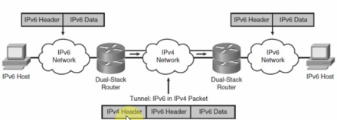

* Translation techniques
  + NAT-PT is an extension of NAT techniques and it protocol translation services for legacy equipment that cannot be upgraded to IPv6 and for some deployment scenarios
  + A router converts IPv6 packets into IPv4 packets and vice versa, allowing IPv6-only devices to communicate with IPv4-only devices.
    - Scalability may again be an issue because of the resources required on the translator device.
* Tunneling IPv6 Traffic
  + Tunnels can be created manually using:
    - Manual IPv6 tunnels
    - GRE IPv6 tunnels
  + Tunnels can also be created automatically using:
    - IPv4-compatible IPv6 tunnels (now deprecated)
    - 6to4 tunnels
    - ISATAP Tunnels
* Manual tunnel configuration
  + Create a tunnel interface
    - Router (config)# interface tunnel number
  + Create a tunnel interface which is virtual
  + Once in interface configuration mode, configure the tunnel parameters including:
    - IP address
    - Tunnel source
    - Tunnel destination
    - Tunnel mode (type of tunnel)
  + Example:

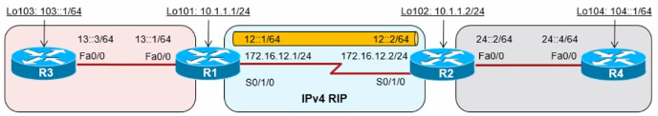

# **ISATAP Tunnels**

* An Intra-Site Automatic Tunnel Addressing Protocol (ISATAP) tunnel is very similar to a 6to4 IPv6 tunnel
  + It is used to connect IPv6 domains over an IPv4 network
  + It embeds an IPv4 address within the IPv6 address
* The goal of ISATAP is to provide connectivity for IPv6 hosts to a centralized IPv6-capable router, over an IPv4-only access network.
* ISATAP was designed to transport IPv6 packets within a site (hence the “intra-site” part of its name)
  + It can still be used between sites, but its purpose is within sites
* ISATAP tunnels use IPv6 addresses consisting of a 64-bit prefix concatenated to a 64-bit interface ID in EUI-64 format

# **Multiprotocol Label Switching (MPLS)**

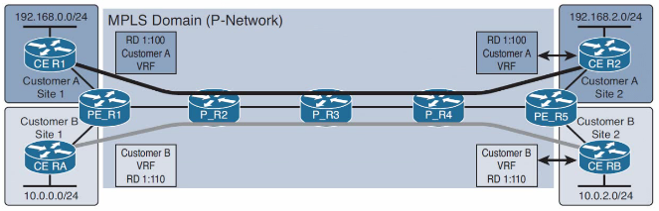

* Originally Cisco proprietary
  + Previously called “tag switching”
* Now an Open standard
  + RFC 3031 – Multiprotocol Label Switching Architecture
* Name implies two important parts:
  + Multiprotocol
  + Label switching
* Multiprotocol
  + Layer 2 payloads
    - Ethernet, Frame Relay, ATM, PPP, HDLC, etc.
  + Layer 3 payloads
    - IPv4, IPv6, etc.
  + Extensible for new future payloads
* Label Switching
  + Switches traffic between interfaces based on locally significant label values
* Similar to a legacy virtual circuit switching
  + Frame Relay input/output DLCI
  + ATM input/output VPI/VCI
* Why use MPLS?:
  + Transparent tunneling over SP network
  + BGP free core
    - Saves routing table space on Provider (P) routers
  + Offer L2/L3 VPN service to customers
    - No need for overlay VPN model
  + Traffic engineering
    - Distribute load over underutilized links
    - Give bandwidth guarantees
    - Route based on service type
    - Detect and repair failures quickly
      * i.e. Fast Reroute (FRR)
* MPLS Label Format
  + RFC 3032 – MPLS Label Stack Encoding
  + 4 byte header used to „switch“ packets
    - 20 bit Label = Locally significant to router
    - 3 bit EXP = Class of Service
    - S bit = Defines last label in the label stack
    - 8 bit TTL = Time To Live
* How Labels Work?
  + MPLS Labels are bound to FECs
    - Forwarding Equivalency Class
    - IPv4 prefix for our purposes
  + Router uses MPLS LFIB instead of IP routing table to switch traffic
  + Switching logic
    - If traffic comes in if1 with label X send it out if2 with label Y
* MPLS Device Roles
  + Customer Edge (CE)
    - Last hop device in customer’s network that connects to provider’s network
    - Can be layer 2 or layer 3 aware
  + Provider Edge (PE)
    - Previously called Label Edge Routers (LER)
    - Last hop device in provider’s network that connects to CE and Provider (P) core devices
    - PE performs both IP routing & MPLS lookups
    - For traffic from customer to core
      * Receives unlabeled packets (e.g. IPv4)
      * Adds one or more MPLS labels
      * Forwards labeled packet to core
    - For traffic from core to customer
      * Recieves MPLS labeled packets
      * Remove one or more MPLS labels
      * Forwards packet to customer
  + Provider (P)
    - Previously called Label Switch Router (LSR)
    - Core devices in providers network that connect to Pes and/or other P routers
    - Switches traffic based only on MPLS labels
* MPLS Device Operations
  + PE & P routers perform three major MPLS operations
    - Label push
      * Add a label to an incoming packet
      * Also known as label imposition
    - Label swap
      * Replace the label on an incoming packet
    - Label pop
      * Remove the label from an outgoing packet
      * Also known as label disposition
* Label Distribution
  + Labels are advertised via a Label Distribution Protocol
  + Label Distribution Protocol (LDP)
    - Advertises labels for IGP learned routes
      * RFC 5036 – LDP Specification
  + MP-BGP
    - Advertises labels for BGP learned routes
      * RFC 3107 – Carrying Label Information in BGP-4
  + RSVP
    - Used for MPLS Traffic Engineering (MPLS TE)
      * RFC 3209 – RSVP-TE : Extensions to RSVP for LSP Tunnels
* Tunnels – The Ultimate Band-Aid
  + Simple transit solution is to tunnel traffic over core from ingress to egress
    - Only the ingress and egress devices need full end-to-end information
    - Core only needs info about ingress and egress devices
  + How can we tunnel?
    - QinQ, GRE, IPinIP, MPLS, etc.
    - MPLS is de-facto standard
* Where MPLS fits in
  + MPLS is the core’s tunnel encapsulation
    - Same exact logic as GRE
  + MPLS is more flexible
    - Arbitrary transport
    - Arbitrary payload
    - Extensible applications
* Example Case – BGP over MPLS over Core
  + Form an MPLS tunnel from ingress to egress
    - Typically IGP + LDP is used for this
    - Could be BGP or RSVP (MPLS TE)
  + Peer BGP from ingress to egress
* Label Distribution Protocol (LDP) Operations
  + Discovering LDP Neighbors
  + Forming LDP Adjacencies
  + Advertising Labels
  + LDP configuration
  + LDP verification
* Discovering LDP Neighbors
  + Like IGPs, LDP automatically discovers neighbors with a Hello protocol
  + Hellos use multiple UDP
    - 224.0.0.2 – “All Routers Multicast”
    - UDP src & dst port 646
  + Hello include “IPv4 Transport Address”
    - Address to use for the TCP session
    - Defaults to the LDP Router-ID

# **IPsec VPN Fundamentals**

* What is VPN?
  + Virtual Private Network(VPN)
    - Extension of private network over public network
    - VPN doesn’t necessarily imply encryption
  + For instance …
    - Layer 2 VPNs
      * Ethernet Vlans, QinQ, Frame Relay PVCs, ATM PVCs, VPLS
    - Layer 3 VPNs
      * GRE, MPLS, Layer3 VPN, IPsec
* What is IPsec?
  + IPsec is a standards based security framework
  + IPsec RFCs include:
    - RFC 2408
      * Internet Security Association and key Management Protocol (ISAKMP)
    - RFC 2409
      * The Internet Key Exchange (IKE)
    - RFC 4302
      * IP Authentication Header
    - RFC 4303
      * IP Encapsulating Security Payload (ESP)
    - RFC 5996
      * Internet Key Exchange Protocol Version 2 (IKEv2)
* IPsec Security Services
  + IPsec main Security Services:
    - Data origin authentication
      * Who did the packet come from?
    - Data confidentiality
      * Can anyone read the packet in transit path?
    - Data integrity
      * Was the packet changed in transit path?
    - Anti-replay
      * Did I already receive this packet?

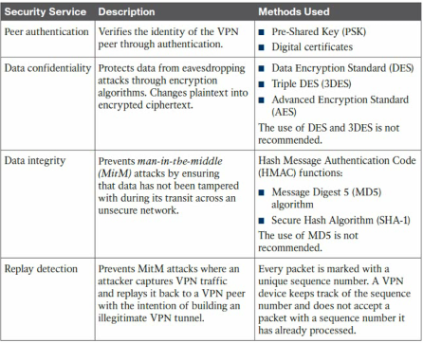

* Why use IPsec VPN?
  + Does not need static SP Provisioning like MPLS
  + Independent of SP access method
    - IPv4/IPv6 transport is the only requirement
  + Allows both site-to-site and remote access
    - Always on vs. dial-on-demand
  + Offers data protection
    - Main motivation for IPsec
* How IPsec Works?
  + IPsec is a Network Layer Protocol (Layer 3)
    - Different from SSL (L7) pr 802.1AE MACSEC (L2)
  + Main goal is to encrypt and authenticate IPv4/IPv6 packets
    - Uses symmetric ciphers for encryption (e.g. 3DES, AES)
    - Keyed hashing for authentication (e.g. MD5, SHA)
  + In most cases used to create P2P tunnels between endpoints
* How IPsec Tunnels Works?
  + Tunnels are dynamically negotiated through IKE
    - Main goal is to Not define crypto keys manually
  + IPsec uses two data structures to build a tunnel
    - Security Association (SA)
      * An agreement of IPsec parameters
      * Maintains encryption & authentication keys on peers
    - Security Parameter Index (SPI)
      * Field in packet header to select SA on receiver
      * Analogous to VLAN header or MPLS label
* SA Negotiation Protocols
  + ISAKMP/IKE are the negotiation protocols used to form SAs
  + Internet Security Association and Management Protocol (ISAKMP)
    - ISAKMP is the framework, says that authentication and keying should occure
    - Internet Key Exchange (IKE)
      * IKE is the actual implementation that defines how authentication and keying occurs
    - ISAKMP/IKE terms are interchangeable
* IKE Versions
  + IKEv1 was the original implementation
    - Spread across lots of RFCs
    - Problems with interoperability with some features
  + IKEv2 adds new improvements
    - Simplified RFC & packet formats, better interoperability
    - More flexible designs
      * E.g. use pre-shared keys on one side but certificates on other side
    - Supports more secure “Suit B” algorithms
  + No change to IPsec data plane, only control plane
* IPsec Tunnel Negotiation with IKE
  + Goal of IPsec exchange is to establish SAs
    - Occurs through two main negotiation phases using IKE
  + IPsec Phase 1
    - Authentication endpoints and build a secure tunnel for further negotiation
    - Result is called the ISAKMP SA
  + IPsec Phase 2
    - Establish the tunnel used to protect the actual data traffic
    - Result is called the IPsec SA
* IKE Phase 1 (Negotiation the ISAKMP SA)
  + During IKE Phase 1, peers negotiate four main parameters
    - Authentication method
    - Diffie-Hellman group
      * 1 / 2 / 5 / …
    - Encryption type
      * DES / 3DES / AES
    - Hash algorithm
      * MD5 / SHA1
  + IKE Authentication
    - Authentication occurs in mainly two ways
      * Pre-Shared Key (PSK)
      * X.509 Certificates (PKI)
    - PSK is easy, but PKI is scalable
      * PSKs are difficult to maintain and change
      * PKI allows easy revocation and also hierarchy
    - IKEv2 adds improved authentication
      * E.g. EAP methods
  + IKE Diffie-Hellman
    - DH is the method to exchange crypto keys
    - DH group number determines strength of keys
      * Highers group is better, but at expense of CPU
    - Result of DH is what 3DES, AES, etc. use as their symmetric keys
  + IKE Encryption
    - Encryption algorithm used to protect the traffic
      * DES, 3DES, AES-128, AES-256, etc.
      * Higher is better but at the expense of CPU
      * Some can be hardware accelerated
        + i.e. AES crypto offload card
      * IKEv2 introduces new enhancements
        + RFC 4307

Cryptographic algorithms for use in the Internet Key Exchange Version 2 (IKEv2)

* + IKE Hashing
    - One way hash used to authenticate the packet
      * If hashes match, the packet was not modified in transit
      * Higher is better, but again at the expense of CPU
    - Hashes supported depends on IKE version
      * IKEv1 MD5 & SHA-1
      * IKEv2 SHA-256, SHA-384, etc.
  + ISAKMP Policies (End of Phase 1)
    - Combinations of IKE params are ISAKMP Policy
      * IKE initiator sends all its policies through a proposal
      * IKE responder checks received policies against its own
      * First match is used, based on lowest local priority value
      * Else, connection is rejected
    - After Phase 1 completes, an encrypted tunnel exists between the peers
      * Phase 2 negotiation can now be hidden from devices in transit
* IKE Phase 2 (Negotiation the IPSEC SA)
  + In phase 2, peers agree on more parameters:
    - Security protocol
      * Encapsulation Security Payload (ESP) or Authentication Header (AH)
    - Encapsulation mode
      * Tunnel mode or Transport mode
    - Encryption
      * DES, 3DES, AES, etc.
    - Authentication
      * MD5, SHA, SHA-256, SHA-512, etc.
    - Proxy Identities
      * Defines what traffic will be protected
      * Also called “Proxy ACLs”
    - Security Association (SA) Lifetimes
      * How often we re-key
    - Perfect Forward Secrecy (PFS)
      * Should we re-negotiate DH before we re-key
    - Combination of these is called the IPsec transform set
* IPsec Packet Headers (AH vs. ESP)
  + Authentication Header (AH)
    - IP protocol number 51
    - Data origin authentication includes IP header
    - Data integrity
  + Encapsulation Security Payload (ESP)
    - IP protocol number 50
    - Data origin authentication excludes IP header
    - Data integrity
    - Data encryption
    - Anti-replay
  + AH supports only authentication
    - Rarely used for VPNs due to this reason
    - IPv6 OSPFv3 can use AH for neighboring authentication
  + ESP supports authentication & encryption
    - Preferred method of IPsec VPNs
    - Most remote access clients only support ESP
* IPsec Packet Transport (Tunnel mode vs. Transport mode)
  + AH & ESP support two modes of encapsulation:
    - Transport Mode
      * Original IP header retained
      * Payload and layer 4 header authenticated/encrypted with ESP
      * Complete packet authentication with AH
      * Typically used in host-to-host IPsec
    - Tunnel Mode
      * Adds new IP header
      * Original header & payload authenticated/encrypted with ESP
      * Complete packet authentication with AH
      * Typically used between IPsec gateways or host to IPsec gateway
* Transport vs. Tunnel Mode Packet Format
  + (Transport Mode)

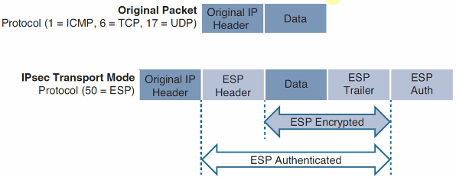

* + (Tunnel Mode)

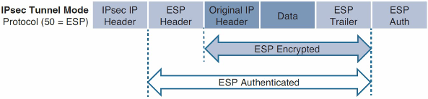

* IPsec Proxy Identities
  + Defines what traffic goes into the IPsec tunnel
    - i.e. the “interesting traffic” to trigger the tunnel
  + Proxy ACLs should be mirror images
    - Take a tunnel from peer A to peer B
    - Peer A says traffic is from X to Y
    - Peer B says traffic is from Y to X
  + Like any other parameter mismatch, misconfiguration will cause tunnel failure
* SA Lifetime
  + ISAKMP / IPsec SA both have finite lifetimes
    - Before expiration, SA is re-keyed
    - Lifetime can be in time or bits
    - Lower value of Initiator or Receiver is negotiated
  + What do we re-key with?
    - Previous DH exchange or new DH exchange?
    - Depend on PFS
* Perfect Forward Secrecy (PFS
  + Without PFS, IPsec SA rekeying is done from the initially negotiated master key
    - One compromised key theoretically means all keys compromised
  + PFS causes new DH exchange prior to rekeying
    - Makes IPsec SA keys independent from previous ones
    - More secure but at the expense of CPU
* IPsec Control Plane vs. Data Plane
  + All traffic is unicast IPv4/IPv6
  + IPsec Control Plane (ISAKMP)
    - UDP 500
    - UDP 4500 if going through NAT
  + IPsec Data Plane
    - ESP (50) or AH (51)
    - ESP over UDP 4500 if going through NAT
  + Some platforms allow custom ports
    - E.g. ASA firewall
* IPsec VPN Configuration
  + Crypto MAP Based IPsec
    - Legacy method of IOS IPsec configuration
      * Still the most common method through
    - Used to form on-demand IPsec tunnels
      * Session initiated only when interesting traffic detected
    - No dynamic routing supported through tunnel
      * Not without additional encapsulation such as GRE
  + How Crypto Maps Work?
    - Crypto map is a data-plane filter
      * Matching traffic triggers an ISAKMP session to start
    - Traffic is matched using ACLs
      * ACLs define proxy IDs for IPsec Phase 2
      * E.g. what should be encrypted
    - Allows for granular control over VPN traffic
      * E.g. only send specific TCP port over the VPN
  + Applying Crypto Maps
    - Crypto maps apply to physical (sub) interfaces
      * Only one crypto map per interface
      * Always outbound with respect to traffic direction
    - One crypto map can apply to multiple interfaces
      * Entries processed top-down until ACL match occurs
      * Order is important
    - Tunnel source defaults to interface IP
      * Can be changed using crypto-map local-address
  + Crypto-Maps Order of Operations
    - Encryption applies after routing
      * Static routing may be required
    - Encryption applies after NAT
      * NAT exemption may be required
    - Rule of thumb is that crypto, routing and NAT processes are always independent of each other
  + High Level Configuration Steps
    - Define Phase 1 ISAKMP Policy
    - Define Phase 2 IPsec Policy
    - Apply Crypto Map
    - Generate interesting traffic
  + ISAKMP Policy – Phase 1
    - Peers must agree on four main attributes
      * Authentication
      * Encryption
      * Hash
      * DH Group
      * Lifetime (lower value is negotiated)
    - Policy is processed top-down until a match occurs by the responder
      * Based on policy priority
      * Lower priority value has higher precedence
      * Order is important
  + IPsec Policy – Phase 2
    - IPsec policy defines three main attributes:
      * Who?
        + Define peer address, hostname, or FQDN
      * What?
        + Define Proxy ACL
      * How?
        + Define Transform Set
  + Applying the Cypto Map
    - Crypto map applies to the link level
      * On interface closest to the destination
        + i.e. how do I route there?
      * Multiple routes means multiple interfaces
  + IPsec Default Policies (Phase 1 & 2)
    - IOS includes default fallback policies
    - Default ISAKMP policies
      * Active until user-configurable policies are created
      * Can be disabled with “*no crypto isakmp default policy*”
    - Default transform-sets
      * Active if user-configurable set is not applied
      * Can be disabled with “*no crypto ipsec transform-set default*”
  + Configuration Steps
    - **Step 1: Configure Interesting Traffic**
    - **Step 2: Configure Phase 1 (ISAKMP)**
      * Encryption **3des** or **aes**
      * Hash **md5** or **sha**
      * Authentication **pre-share**
      * Diffie-Helman Group **2** or **5**
    - **Step 3: Configure Phase 2 (IPsec)**
      * i.e:
        + *crypto ipsec transform-set TRSET esp-3des esp-md5-hmac*
        + *crypto map VPNMAP 10 ipsec-isakmp* (set peer, set transform-set, match address)
    - **Step 4: Apply crypto map to interface**
    - **Step 5: Verify Encrypted Data Transfer**
      * *Show crypto isakmp sa*
      * *Show crypto ipsec sa*
* Configuration verification
  + Show crypto isakmp [default] policy
    - Verify custom or default Phase 1 policies
  + Show vrypto isakmp key
    - Verify pre-shared-keys
  + Show crypto ipsec transform-set <name>
    - Verify custom or default Phase 2 policies
  + Show crypto debug-condition
    - Verify conditions/filters for debugging
  + Show crypto map interface <intf>
    - Verify crypto-map configuration
* Advanced verifications
  + Show crypto isakmp sa
    - Show the result of Phase 1 negotiation
  + Debug crypto isakmp
    - Show the step-by-step Phase 1 negotiation
  + Show crypto ipsec sa
    - Show the result of Phase 2 negotiation
  + Debug crypto ipsec
    - Show the step-by-step Phase 2 negotiation
* GRE Over IPsec
  + Why use GRE and IPsec together?
    - Crypto maps have no interface in routing table
      * Static routing is hard to scale
      * BGP could be used, but overcomplicates the design
    - Simple solution, add a tunnel interface
      * Run routing inside of a GRE tunnel
      * Encrypt GRE tunnel inside of IPsec
  + Why does the Crypto Map apply?
    - If crypto map attached at physical interface
      * GRE over IPsec (IPsec is transport)
      * GRE encapsulation first, encryption second
      * Proxy-ACL with single entry “permit gre host A host B”
    - If crypto map attached at tunnel interface level
      * IPsec over GRE (GRE is transport)
      * Encryption first, GRE second
      * Proxy-ACL with end-to-end entries
      * Bad design
  + GRE over IPsec vs. IPsec Tunnel Mode

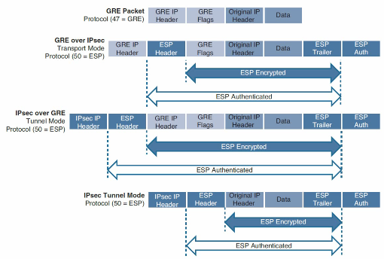

* + GRE over IPsec – Fragmentation Problems
    - Overhead is negligible, why do we care?
      * Extra 20 byte is only about 1% overhead of 1500 byte MTU
    - DF bit isn’t copied between header
      * PMTUD is now broken
      * Router must encrypt, then fragment
      * Throughput is now out of window
    - How to fix it?
      * Offload fragmentation to the end host
  + IP MTU and TCP Adjust MSS
    - How to offload fragmentation to the host?
      * Lower IP MTU on GRE to account for ESP overhead
      * Actual overhead varies based on crypto algorithm
        + E.g. AES uses 16-byte blocks
      * Good rule of thumb is about 1400 bytes normal MTU
      * Jumbo MTU rule of thumb about 9000 bytes
    - What if host doesn’t implement PMTUD?
      * Edit their MSS in TCP SYN & SYN ACK
      * TCP Adjust MSS is IP MTU – 20 byte IP – 20 byte TCP
* IPsec Virtual Tunnel Interface (VTI)
  + Site-to-Site GRE over IPsec
    - IPsec Virtual Tunnel Interfaces (VTI)
    - Crypto IPsec Profile
  + Tunnel interface with direct IPsec encapsulation
    - Conceptually similar with GRE, but without additional GRE overhead
  + VTI variations includes:
    - Static VTI (SVTI)
      * Used for site-to-site VPN
    - Dynamic VTI (DVTI)
      * Used for remote-access VPN
* GRE over IPsec vs. IPsec VTI (VTI)

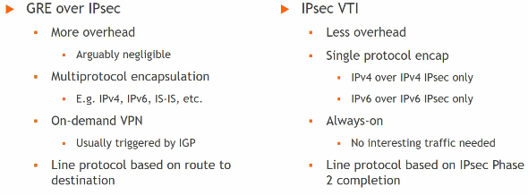

* IPsec VTI Configuration
  + Phase 1 steps are identical to crypto map based tunnel
  + Phase 2 steps:
    - Tunnel already defines the Who
      * i.e. tunnel destination
    - tunnel already defines the What
      * i.e. IP any any
    - How is the traffic treated?
      * Defined by Crypto Ipsec Profile
  + Configuration Steps
    - **Step 1: Configure the GRE Tunnel**
    - **Step 2: Configure Routing to reach the remote subnets**
    - **Step 3: Configure IPsec Phase 1** 
      * Encryption **3des** or **aes**
      * Hash **md5** or **sha**
      * Authentication **pre-share**
      * Diffie-Helman Group **2** or **5**
    - **Step 3: Configure Phase 2 (IPsec Profile)**
      * i.e:
        + *crypto ipsec transform-set TRSET esp-3des esp-md5-hmac*
        + *crypto ipsec profile GRE-PROTECTION*

*set transform-set TRSET*

* + - **Step 5: Attach the IPsec Protocation profile to GRE Tunnel**
      * *Interface tunnel 0*
        + *Tunnel protection ipsec profile GRE-PROTECTION*

# **DMVPN (Dynamic Multipoint VPN) Tunnels**

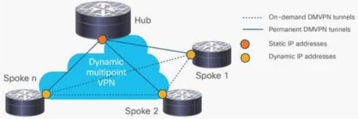

* What is DMVPN?
  + Point-to-multipoint layer 3 overlay VPN
    - Logical hub and spoke topology
    - Direct spoke to spoke traffic is supported
* DMVPN uses a combination of:
  + Multipoint GRE Tunnels (mGRE)
  + Next Hop Resolution Protocol (NHRP)
  + IPsec Crypto Profiles
  + Routing
* Why use DMVPN?
  + Independent of SP access method
    - Only requirement is IP connectivity
  + Routing policy is not dictated by SP
    - E.g. MPLS L3VPN restrictions
  + Highly scalable
    - If properly designed
* DMVPN Concepts and Components
  + Hub Router
    - Reachable via static, public IP address
  + Spoke Routers
    - Reachable via static, or dynamic, public IP addresses
  + Multipoint GRE tunnels
  + IPsec (optional, but typically used)
* DMVPN benefits
  + Zero-touch provisioning
    - DMVPN hubs do not require additional configuration when additional spokes are added
  + Scalable deployment
    - Minimal peering and minimal permanent state on spoke routers allow for massive scale
  + Spoke-to-spoke tunnels
    - DMVPN provides full-mesh connectivity while requiring configuration of only the initial spoke-to-hub tunnels
    - Dynamic spoke-to-spoke tunnels are created as needed and torn down when no longer needed
  + Flexible network topologies
    - DMVPN operation does not make any rigid assumptions about either the control plane or data plane overlay topologies
  + Multiprotocol support
    - DMVPN can use IPv4, IPv6, and MPLS as the overlay or transport network protocol
  + Multicast support
    - DMVPN allows multicast traffic to flow on the tunnel interface
  + Adaptable connectivity
    - DMVPN routers can establish connectivity behind Network Address Translation(NAT)
  + Standardized building blocks
    - DMVPN uses industry-standardized technologies (NHRP, GRE, and IPsec) to build an overlay network
* Generic Routing Encapsulation (GRE) Tunnels
  + A GRE tunnel provides connectivity to a wide variety of network layer protocols by encapsulating and forwarding those packets over an IP-based network
  + The original use of GRE tunnels was to provide a transport mechanism for nonroutable legacy protocols such as DECnet, Systems Network Architecture (SNA), and IPX
* Next Hop Resolution Protocol (NHRP)
  + Defined in RFC 2332 as a method to provide address resolution for hosts or networks (with ARP-like capability) for Nonbroadcast Multi-Access (NBMA) networks such as Frame Relay and ATM networks
  + NHRP provides a method for devices to learn the protocol and NBMA network, thereby allowing them to directly communicate with each other
  + NHRP is a client/server protocol that allows devices to register themselves over directly connected or disparate networks
  + NHRP Next-Hop Servers (NHSs) are responsible for registering addresses or networks, maintaining an NHRP repository, and replying to any query received by Next-Hop Clients (NHCs)
  + DMVPN uses mGRE tunnels and therefore requires a method of mapping tunnel IP addresses to the transport (underlay) IP address. HHRP provides the technology for mapping those IP addresses.
  + Used in DMVPN to map a peer’s tunnel IP address to that peer’s public IP address
* How DMVPN Works?

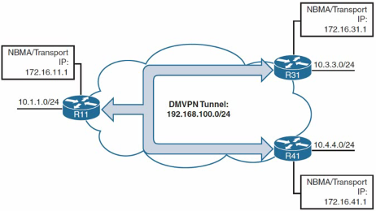

* + Tunnel interfaces created on each router including:
    - Tunnel Source (public IP address)
    - Tunnel Mode GRE Multipoint
  + Next Hop Server (Hub) statically defined in spoke an static NHRP Cache entry created
* DMVPN Phases
  + Hub and spoke only
  + Adds Spoke-to-Spoke Capability
    - In this phase, all spoke routers must know all IP routers of all other spoke routers
  + Modification of routing behavior
    - Hub allowed to summarize all routers from spokes
    - Sets the next-hop of summarized routers to itself
    - Hub can send NHRP Redirect Message to Spokes
* DMVPN Summary
  + Creates on-demand tunnels between nodes
    - Initial tunnel-mesh is hub-and-spoke (always on)
    - Traffic patterns trigger spoke-to-spoke tunnels
    - Solve management scalability problem
  + Maintains tunnels based on traffic patterns
    - Spoke-to-spoke tunnel is on-demand
    - Spoke-to-spoke tunnel lifetime is based on traffic
  + Requires two IGPs
    - Underlay and Overlay
      * IPv4/IPv6 supported on both passenger and transport

# **Secure Network Access Control**

* Router access control lists (RACL)
  + Supported in the TCAM hardware on Cisco multilayer switches. In catalyst switches, RACL can be applied to any routed interface, such as SVI or routed port.
* Port access control list (PACL):
  + Filters traffic at the port level. PACL’s can be applied on a Layer 2 switch port, trunk port, or EtherChannel port. PACL’s act at the Layer 2 port level but can filter based on Layer 3/Layer 4 information.
* VACL’s:
  + Also known as VLAN access-maps, apply to all traffic in a VLAN. VACL’s support filtering based on Ethertype and MAC addresses. VACL’s are order-sensitive, analogous to route maps. VACL’s can control traffic flowing within the VLAN or control switched traffic, whereas RACL’s control only routed traffic.

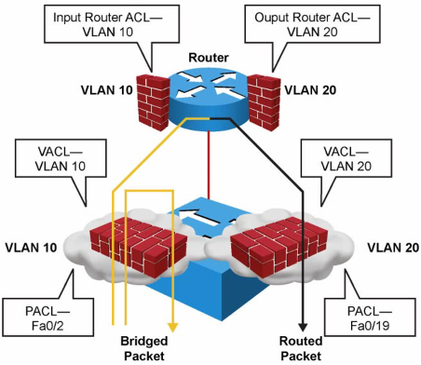

* Private VLANs
  + Service providers often have devices from multiple clients, in addition to their own servers, in a single Demilitarized Zone (DMZ) segment or VLAN. As security issues abound, it becomes more important to provide traffic isolation between devices, even though they might exist on the same Layer 3 segment and VLAN.
  + Private VLAN types
    - Primary
    - Isolated
    - Community
  + Private VLAN port types
    - Promiscuous
    - Host

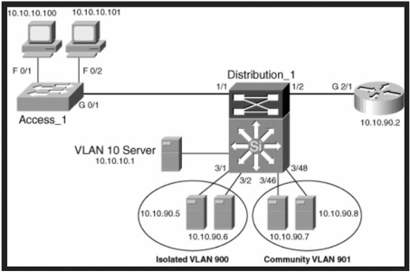

* + pVLAN structure supporting VLANS
    - Primary Private VLAN
    - Secondary Private VLAN
      * Community Private VLAN
      * Isolated Private VLAN
  + Configuring pVLANs – Steps
    - Step 1. Set VTP mode to transparent
    - Step 2. Create the secondary pVLANs
    - Step 3. Create the Primary pVLAN
    - Step 4. Associate the secondary pVLAN with the primary pVLAN
      * Only one isolated pVLAN can be mapped to a primary pVLAN, but more than one community pVLAN can be mapped to a primary pVLAN
    - Step 5. Configure an interface as an isolated or community port
    - Step 6. Associate the isolated port or community port with the primary-secondary pVLAN pair
    - Step 7. Configure an interface as a promiscuous port
    - Step 8. Map the promiscuous port to the primary-secondary pVLAN pair
  + pVLAN Edge (Protected Port)
    - The PVLAN edge (protected port) feature has only local significance to the switch (unlike pVLANs), and there is no isolation provided between two protected ports located on different switches.

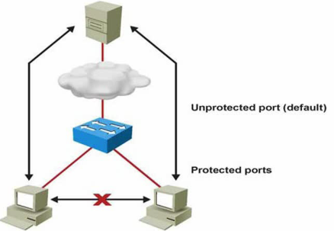

# **Network Security Design for Threat Defense**

* Cisco SAFE (Security Architecture Framework for the Enterprise)
  + Helps designing secure solutions for the following places in the network which are called PINs (Places In the Network):
    - Branch
    - Campus
    - Data Center
    - Edge
    - Cloud
    - WAN
  + Cisco SAFE focuses on the integration of security services within each of the PINs
  + Cisco SAFE also defines source domains, which are operational areas used to protect the different PINs
    - The following security concepts are used to evaluate each PIN:
      * Management
      * Security Intelligence
      * Compliance
      * Segmentation
      * Threat defense
      * Secure services

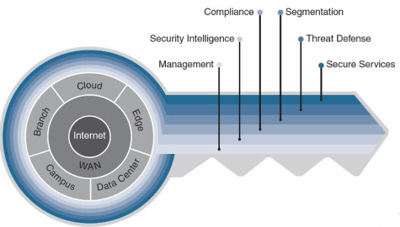

* + Cisco SAFE – Benefits
    - Implementing the Cisco SAFE framework in an organization provides advanced threat defense protection that spans the full attack continuum before, during, and after an attack for all the PINs:

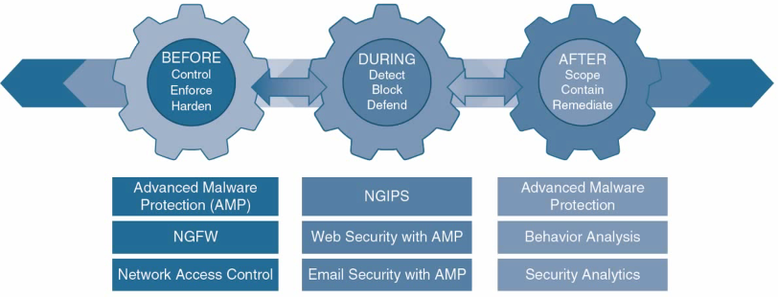

* + Cisco SAFE – Before Attack
    - In this phase, full knowledge of all the assets that need to be protected is required
    - The types of threats that could target these assets need to be identified
    - This phase involves establishing policies and implementing prevention to reduce risk
    - Cisco solutions for this phase include …
      * Next-generation firewalls
      * Network access control
      * Network security analysis
      * Identity services
  + Cisco SAFE – During Attack
    - This phase defines the abilities and actions that are required when an attack gets through
    - Threat analysis and incident response are some of the typical activities associated with this phase
    - For this phase, organizations can leverage …
      * Next-generation intrusion prevention systems
      * Next-generation firewalls
      * Malware protection and email and web security solutions
  + Cisco SAFE – After Attack
    - This phase defines the ability to detect, contain, and remediate an attack
    - After a successful attack, any lessons learned need to be incorporated into existing security solution
    - Organizations can leverage …
      * Organizations can leverage Cisco Advanced Malware Protection, next-generation firewalls, and malicious network behavior analysis using Stealthwatch to quickly and effectively scope, contain, and remediate an attack to minimize damage
  + Cisco SAFE framework critical components
    - Cisco Talos
      * Talos is the Cisco threat intelligent organization, an elite team of security experts who are supported by sophisticated security systems to create threat intelligence that detects, analyzes, and protects against both known and emerging threats for Cisco products
    - Cisco Threat Grid
      * Cisco Threat Grid (acquired by Cisco in 2014) is a solution that can perform static file analysis e.g. checking filenames, MD5 checksums, file types, and so on as well as dynamic file analysis aka. Behavioral analysis
        + Behavioral analysis is combined with threat intelligence feeds from Talos as well as with existing security technologies to protect against known and unknown attacks.
        + It is also possible to upload suspicious files into a sandbox environment called Glovebox to safely interact with them and observe malware behavior directly
    - Cisco Advanced Malware Protection (AMP)
      * Cisco AMP is a malware analysis and protection solution that goes beyond point-in-time detection
      * Cisco AMP provides comprehensive protection for organizations across full attack continuum:
        + Before: global threat intelligence from Cisco Talos and Cisco Threat Grid feeds into AMP to protect against known and new emerging threats
        + During: file reputation to determine whether a file is clean or malicious as well as sandboxing are used to identify threats during an attack
        + After: Cisco AMP provides retrospection, indicators of compromise (IoCs), breach detection, tracking, analysis, and surgical remediation after an attack, when advanced malware has slipped past other defenses.
      * Threat architecture of AMP can be broken down into the following components:
        + AMP Cloud (private or public)
        + AMP connectors

AMP for Endpoints (Microsoft Windows, MacOS X, Google Android, Apple iOS, and Linux)

* + - * + AMP for Networks (NGFW, NGIPS, ISRs)
        + AMP for Email (ESA)
        + AMP for Web (WSA)
        + AMP for Merake MX
        + Threat intelligence from Cisco Talos and Cisco Threat Grid
    - Cisco AnyConnect
      * The Cisco AnyConnect Secure Mobility Client is a modular endpoint software product
      * It is not only a VPN client but also offers enhanced security through various built-in modules, such as …
        + VPN Posture (HostScan) module and an ISE Posture module
        + These modules enable Cisco AnyConnect to assess an endpoint’s compliance for things like antivirus, antispyware, and firewall software installed on the host
        + If an endpoint is found to be noncompliant, network access can be restricted until the endpoint is in compliance
    - Cisco Umbrella
      * Cisco Umbrella provides the first line of defense against threats on the Internet by blocking requests to malicious Internet destinations (domains, IPs, URLs)
        + Using the DNS before an IP connection is established or a file is downloaded
      * It is 100% cloud delivered, with no hardware to install or software to maintain
      * The Umbrella global network includes 30 data centers around the world using Anycast DNS, which allows it to guarantee 100% uptime
    - Cisco Web Security Appliance (WSA)
      * The Cisco WSA is an all-in-one web gateway that includes a wide variety of protections that can block hidden malware from both suspicious and legitimate websites
      * It leverages real-time threat intelligence from Cisco Talos and Cisco AMP Threat Grid

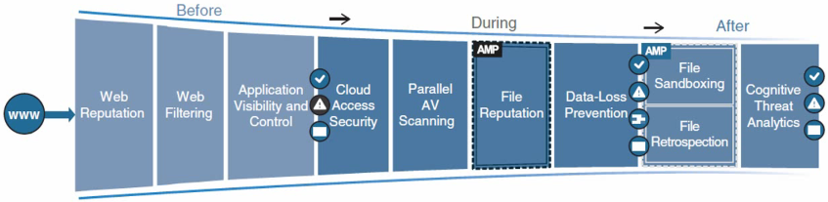

* + - Cisco Email Security Appliance (ESA)
      * The Cisco ESA enables users to communicate securely via email and helps organizations combat email security threats with a multilayered approach across the attack continuum.
    - Next-Generation Intrusion Prevention System (NGIPS)
      * A system that passively monitors and analyzes network traffic for potential intrusion attacks and logs the intrusion attack data for security analysis is known as an Intrusion Detection System (IDS).
      * A system that provides IDS functions and also automatically blocks intrusion attacks is known as an Intrusion Prevention System (IPS)
      * A next-generation IPS (NGIPS) should include IPS functionality as well as following capabilities:
        + Real-time contextual awareness
        + Advanced threat protection
        + Intelligent security automation
        + Unparalleled performance and scalability
        + Application visibility and control (AVC) and URL filtering
    - Next-Generation Firewall (NGFW)
      * In addition to providing standard firewall functionality, a next-generation firewall(NGFW) can block threats such as advanced malware and application-layer attacks.
      * NGFW firewall must include:
        + Standard firewall capabilities such as stateful inspection
        + An integrated IPS
        + Application-level inspection (to block malicious or risky apps)
        + The ability to leverage external security intelligence to address evolving security threats
      * Firewall NGFW is available on the following hardware appliances:
        + Firepower series appliances
        + All ASA 5500-X appliances (except 5585-X)
      * The Firepower NGFW appliances support the following software:
        + ASA software image
        + ASA software image with Firepower Services Software Image (NGIPS)
        + Firepower Threat Defense (FTD) software image
      * FTD is also supported on the following platforms:
        + ISR(Integrated Service Router) modules
        + Firepower virtual NGFW (NGFWv) appliances
      * The following management options are available for NGFWs:
        + For FTD or Firepower Services software:

Firepower Management Center (FMC)

Firepower Device Manager (FDM) for small appliances

* + - * + For ASA software:

CLI

Cisco Security Manager (CSM

Adaptive Security Device Manager (ASDM)

Cisco Defense Orchestrator

* + - Cisco Stealthwatch
      * Cisco Stealthwatch is a collector and aggregator of network telemetry that performs network security analysis and monitoring to automatically detect threats
      * Using advanced security analytics, Stealthwatch can quickly and with high confidence detects threats such as …
        + Command-and-control (C&C) attacks
        + Ransomware
        + DDoS attacks
        + Ilicit cryptomining
        + Unknown malware
        + Inside threats
    - Cisco Identity Services Engine (ISE)
      * Cisco ISE is a security policy management platform that provides highly secure network access control (NAC) to users and devices across wired, wireless, and VPN connections
      * It allows for visibility into what is happening in the network, such as:
        + Who is connected (endpoints, users, and devices)
        + Which applications are installed and running on endpoints
        + And much more …
      * Some of the most important ISE features:
        + Streamlined network visibility
        + Cisco Digital Network Architecture (DNA) Center Integration
        + Centralized device access control
        + Cisco TrustSec
        + Guest lifecycle management
        + Device profiling
        + Endpoint posture service
        + Active directory support
        + Cisco Platform Exchange Grid (pxGrid) and …

# **Network Access Control (NAC)**

* IEEE 802.1x
  + IEEE 802.1x is a standard for port-based network access control (PNAC) that provides an authentication mechanism for LANS and WLANS
  + 802.1x comprises the following components:
    - Extensible Authentication Protocol (EAP)
      * This message format and framework defined by RFC 4187 provides an encapsulated transport for authentication parameters
    - EAP method (also referred to as EAP type)
      * Different authentication methods can be used with EAP
    - EAP over LAN (EAPoL)
      * This Layer 2 encapsulation protocol is defined by 802.1x for the transport of EAP messages over IEEE 802 wired and wireless networks
    - RADIUS prtotocol
      * This is the AAA protocol used by EAP
  + 802.1x network devices have the following roles:
    - Supplicant (end user)
    - Authenticator (e.g. router)
    - Authentication Server (e.g. ISE, ACS)

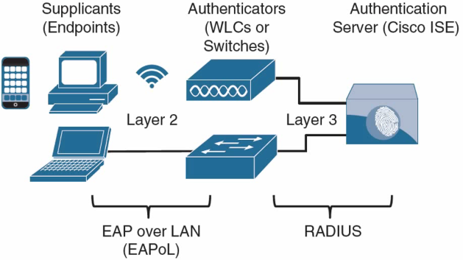

* + 802.1x Authentication Process Flow:
    1. When the authenticator notices a port coming up, it starts the authentication process by sending periodic EAP-request/identity frames. The supplicant can also initiate the authentication process by sending an EAPoL-start message to the authenticator
    2. The authenticator relays EAP messages between the supplicant and the authentication server, copying the EAP messages in the EAPoL frame to an AV-pair inside a RADIUS packet and vice versa until an EAP method is selected. Authentication then takes place using the selected EAP method.
    3. If authentication is successful, the authentication server returns a RADIUS access-accept message with an encapsulated EAP-success message as well as an authorization option such as a downloadable ACL(dACL). When this is done, authenticator opens the port.
* MAC Authentication Bypass (MAB)
  + MAB is an access control technique that enables port-based access control using the MAC address of an endpoint
  + Is typically used as a fallback mechanism to 802.1x
  + MAB-enabled port can be dynamically enabled or disabled based on the MAC address of the endpoint that connects to it
  + MAB Authentication Process Flow:
    - The switch initiates authentication by sending an EAPoL identity request message to the endpoint every 30 seconds by default. After three timeouts (a period of 90 seconds by default), the switch determines that the endpoint does not have a supplicant and proceeds to authenticate it via MAB.
    - The switch begins MAB by opening the port to accept a single packet from which it will learn the source MAC address of the endpoint. Packets sent before the port has fallen back to MAB (that is, during IEEE 802.1x timeout phase) are discarded immediately and cannot be used to learn the MAC address. After the switch learns the source MAC address, it discards the packet. It crafts a RADIUS access-request message using the endpoint’s MAC address as the identity. The RADIUS server receives the RADIUS access-request message and performs MAC authentication.
    - The RADIUS server determines whether the device should be granted access to the network and, if so, what level of access to provide. The RADIUS server sends the RADIUS response (access-accept) to the authenticator, allowing the endpoint to access the network. It can also include authorization options such as dACLs, dVLANs, and SGT tags.
* Web Authentication (WebAuth)
  + There are two types of WebAuth:
    - Local Web Authentication
    - Centralized Web Authentication with Cisco ISE
  + Centralized Web Authentication (CWA) step details:
    - The endpoint entering the network does not have a configured supplicant or the supplicant is misconfigured
    - The switch performs MAB, sending the RADIUS access-arequest to Cisco ISE (the authentication server)
    - The authentication server (ISE) sends the RADIUS result, including a URL redirection, to the centralized portal on the ISE server itself.
    - The endpoint is assigned an IP address, DNS server, and default gateway using DHCP.
    - The end user opens a browser and enters credentials into the centralized web portal. Unlike with LWA, the credentials are stored in ISE and are tied together with the MAB coming from the switch.
* Enhanced Flexible Authentication (FlexAuth)
  + By default, a cisco switch configured with 802.1x, MAB, and WebAuth always attempt 802.1x authentication first, followed by MAB, and finally WebAuth
    - If an endpoint that does not support 802.1x tries to connect to the network, it needs to wait for a considered amount of time before WebAuth is offered as an authentication option
  + Enhanced FlexAuth addresses this problem by allowing multiple authentication methods concurrently. E.g. 802.1x and MAB
    - So that endpoints can be authenticated and brought online more quickly
  + Enhanced FlexAuth is a key component of the Cisco Identity Based Networking Services (IBNS) 2.0 integrated solution, which offers authentication, access control, and user policy enforcement.
* Cisco Identity-Based Networking Services (IBNS) 2.0
  + Cisco IBNS 2.0 is an integrated solution that offers authentication, access control, and user policy enforcement with a common end-to-end access policy that applies to both wired and wireless networks
  + IBNS is a combination of the following existing features and products:
    - Enhanced FlexAuth (Access Session Manager)
    - Cisco Common Classification Policy Language (C3PL)
    - Cisco ISE
* Cisco TrustSec
  + TrustSec is a next-generation access control enforcement solution developed by cisco to address the growing operational challenges related to maintaining firewall rules and ACLs by using Security Group Tag (SGT) tags.
  + TrustSec uses SGT tags to perform ingress tagging and egress filtering to enforce access control policy
    - Cisco ISE assigns the SGT tags to users or devices that are successfully authenticated and authorized through 802.1x, MAB or WebAuth.
    - The SGT tag assignment is delivered to the authenticator as an authorization option
    - After the SGT tag is assigned, an access enforcement policy (allow or drop) based on the SGT tag can be applied at any egress point of the TrustSec network.
    - SGT tags represent the context of the user, device, use case, or function.
* MACsec
  + MACsec is an IEEE 802.1AE standards-based Layer 2 hop-by-hop encryption method
    - This means the traffic is encrypted only on the wire between two MACsec peers and is unencrypted as it is processed internally within the switch
    - This allows the switch to look into the inner packets for things like SGT tags to perform packet enforcement or QoS prioritization.
    - MACsec also leverages onboard ASICs to perform the encryption and decryption rather than having to offload to a crypto engine, as with IPsec
  + MACsec is based on the Ethernet frame format; however, an additional byte MACsec Security Tag field (802.1AE header) and a 16-byte Integrity Check Value (ICV) field are added.
    - This means that all devices in the flow of the MACsec communications must support MACsec for these fields to be used and to secure the traffic.

# **Network Device Access Control and Infrastructure Security**

* Authentication, Authorization, and Accounting (AAA)
  + AAA is an architectural framework for enabling a set of three independent security functions:
    - Authentication
    - Authorization
    - Accounting
  + AAA requires a protocol designed to carry authentication requests and responses, including authorization results and accounting logs.
    - The two most popular AAA protocols are Remote Authentication Dial-In User Service (RADIUS) and Terminal Access Controller Access-Control System Plus (TACACS+)
  + TACACS+
    - The TACACS+ protocol uses Transmission Control Protocol (TCP) port 49 for communication between the TACACS+ clients and the TACACS+ server.

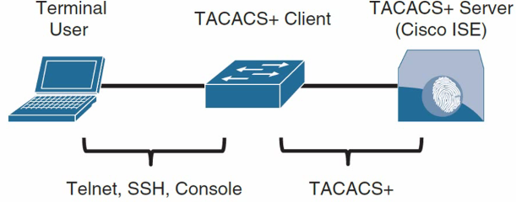

* + RADIUS
    - RADIUS is an IETF standard AAA protocol
      * As with TACACS+, it follows a client/server model, where the client initiates the requests to the server
    - RADIUS is the AAA protocol of choice for secure network access
      * The reason for this is that RADIUS is the AAA protocol for Extensible Authentication Protocol (EAP), while TACACS+ does not support this functionality
    - Another major difference between TACACS+ and RADIUS is that RADIUS needs to return all authorization parameters in a single reply, while TACACS+ can request authorization parameters separately and multiple times throughout a session.
  + RADIUS & TACACS+ Comparison

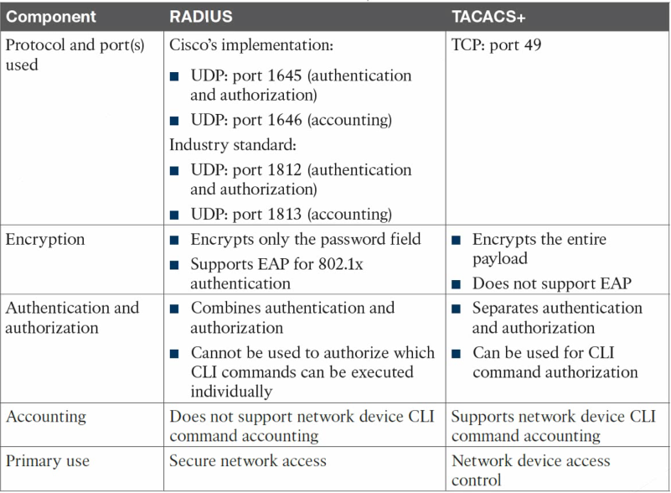

# **Zone-Based Firewall (ZBFW)**

* ACLs control access based on protocol, source IP address, destination IP address, and ports
  + Unfortunately, they are stateless and do not inspect a packet’s payload to detect whether attackers are using a port that they have found open
* Stateful firewalls are capable of looking into layers 4 through 7 of a network packet to verify the state of the transmission
  + A stateful firewall can detect whether a port is being piggybacked and can mitigate DDoS intrusions
* Cisco Zone-Based Firewall (ZBFW) is the latest integrated stateful firewall technology included in IOS. ZBFW reduces the need for a firewall at a branch site to provide stateful network security
* A zone establishes a security border on the network and defines acceptable traffic that is allowed to pass between zones
* By default, interfaces in the same security zone can communicate freely with each other but interfaces in different zones cannot communicate with each other.

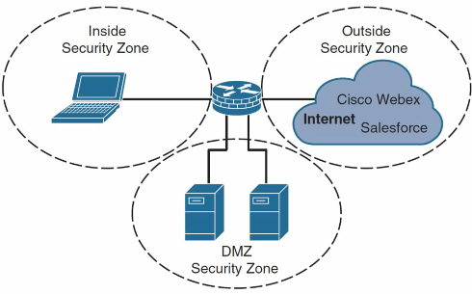

* Within the ZBFW architecture, there are two system-built zones:
  + The self zone
    - The self zone is a system-level zone and indicates all the routers’ IP addresses. By default, traffic to and from this zone is permitted to support management and control
  + The default zone
    - The default zone is a system-level zone, and any interface that is not a member of another security zone is placed in this zone automatically.

# **Intent-Based Networking (IBN)**

* Intent-Based Networking (IBN) is a form of network administrator that incorporates AI, network orchestration and Machine Learning (ML) to automate administrative tasks across a network.

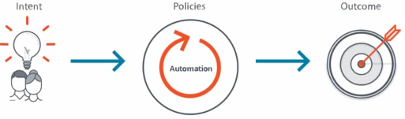

* How does IBN work?
  + IBN captures and translates business intent into network policies that can be automated and applied consistently across the network
  + The end goal is for the network to continuously monitor and adjust network performance to assure the desired business outcome
  + Ultimately, this is achieved through a closed-loop system with the following functional building blocks- **translation**, **activation** and **assurance**.

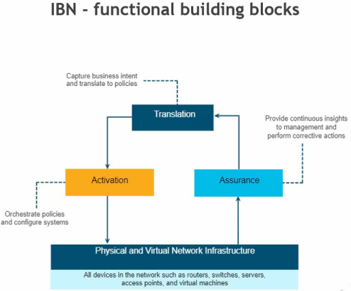

* Cisco Solutions for Intent-Based Networking
  + Cisco Strategy
    - Cisco has a complete architecture and solution suite to deliver on the vision of applying and assuring intent from client to application by using intent-based networking across all networking domains: **Data center**, **Campus**, **Branch**, **WAN**, and **Multicloud**.

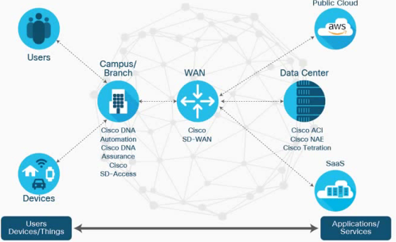

# **Network Management**

* Network Infrastructure Basic Planes
  + Management Plane
    - This includes the protocols and traffic that an administrator uses between his workstation and the network device itself. E.g. SSH
  + Control Plane
    - This includes protocols and traffic that the network devices use on their own without direct interaction from an administrator. E.g. Routing protocol
  + Data Plane
    - This includes traffic that is being forwarded through the network. E.g. a user on one part of the network accessing a server
* Network Management includes:
  + Device installation and configuration
  + Failure response
  + Network monitoring
  + Backup of device configuration and software
  + Software upgrading or patching
  + Performance measurement and capacity planning
  + Security
* Network Automation
  + Network automation is the process of automating the:
    - Configuring
    - Managing
    - Deploying
    - Operating of physical and virtual devices
  + Automation Domain
    - Initial configuration provision
    - Dynamically segregate the traffic path via overlay network
    - Dynamically apply QoS and security policy
    - Schedule software upgrade/path deployment
    - Intelligent solutions to troubleshooting by using AI/ML
    - Network map/topology visualization
  + Network Automation Software and Tools
    - Dedicated software or appliances
      * SDN Controllers – like Cisco ACI
      * Ansible, Puppet, Chef
    - Scripting Languages
      * Built-in scripts – like TCL scripts
      * Python and others

# **Introduction to SDN**

* Software-Defined Networking (SDN) Overview
  + An approach and architecture in networking where control and data planes are decoupled and intelligence and state are logically centralized
  + Enablement where underlying network infrastructure is abstracted from the applications (network virtualization)
  + A concept that leverages programmatic interfaces to enable external system to influence network provisioning, control, and operations.
* Traditional versus Software-Defined Networks
  + The tradition network
    - Control plane learns/computes forwarding decisions
    - Data plane acts on the forwarding decisions
  + Software-Defined Networking
    - Control plane becomes centralized
    - In some cases physical device retains data plane functions only
* SDN Main Definitions and Protocols
  + Open SDN (OpenFlow)
  + SDN using APIs (Cisco Openflex)
  + SDN using Overlays (VMware NSX)
* Open SDN
  + Because of the operating system on network devices is proprietary, we can’t develop our application and protocols to change control and data plane of devices. So we make networking devices open to experts to develop their own application, protocols and utilities that causes innovation in networking.
* SDN Controllers & Centralized Control
  + A controller, or SDN controller, centralizes the control of the networking devices
  + A controller is a software that is pre-installed on an appliance or it could be a software that is installed on a server or even in the cloud. (e.g. Cisco APIC Appliance)
* SDN Controllers & Different approaches
  + SDN ‘Stateful’ approach (Imperative)
  + SDN ‘Stateless’ approach (Declarative)

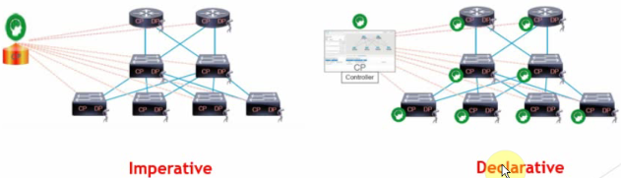

* SDN – Required Network Design
  + The approach to solve addressing and segmentation problems in the new networking era:
    - Underlay Network
      * Basically, “Underlay Network” is the physical infrastructure that is responsible for delivery of packets across networks.
    - Overlay networks
      * An “Overlay Network” is a virtual network that is built on top of underlying network infrastructure
    - Network Fabric
      * Basically, it’s the physical infrastructure which build “Underlay Network” and typically controlled by SDN controller.
  + Underlay Network Characteristics:
    - Layer 3 to the access design
      * The use of a layer 3 routed network for the fabric provides the highest level of availability without the need to used loop avoidance protocols or interface bundling techniques.
    - Use point-point links
      * Point-to-point links provide the quickest convergence times because they eliminate the need to wait for the upper layer timeouts typical of more complex topologies
    - ECMP
      * Equal-cost multi-path routing is a routing strategy where next-hop packet forwarding to a single destination can occur over multiple best paths
  + Overlay Network Characteristics
    - Maintaining isolation among the networks as well as independence from the underlay network
    - Overlay networks can run across all or a subset of the underlay network devices
    - Multiple overlay networks can run across the same underlay network to support multitenancy through virtualization

# **Network APIs and Protocols**

* SDN Controllers, APIs & Protocols
  + Northbound APIs: (REST, Java API, Cisco Intent)
    - Used to connect “Application” to controllers
  + Southbound APIs: (OpenFlow, Cisco Opflex, SNMP, CLI/SSH)
    - Used to connect “Controllers” to network devices

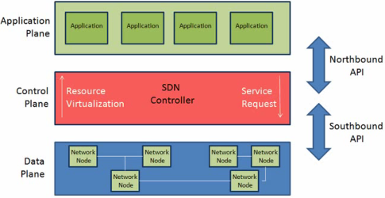

* + Model-Driven Programmability
    - Model-Driven Programmability Stack

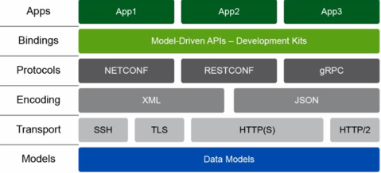

* + - Model Driven Manageability

